THE PUNJAB ENFORCEMENT AND REGULATORY AUTHORITY (APPOINTMENT AND CONDITIONS OF SERVICE FOR CONTRACTUAL EMPLOYEES) (AMENDED) REGULATIONS, 2025
CONTENTS

- Short title and Commencement
- Definitions
- Terms of Reference of Service for Contractual Employees
- Contractual Employment Committee
- Duration and Extension of Contract
- Probation & Confirmation
- Resignation
- Termination of Service
- Guidelines for Fixing Terms and Conditions of Service for Contract Employment
- Repeal
- Savings

SCHEDULES
- Schedule-I - Organizational Structure
- Schedule-II - Terms of Reference for Service
- Schedule-III - Special Pay Package PERA (SPPP)



GOVERNMENT OF THE PUNJAB
PUNJAB ENFORCEMENT AND REGULATORY AUTHORITY
Lahore, Dated the 12th November, 2025

N O T I F I C A T I O N

THE PUNJAB ENFORCEMENT AND REGULATORY AUTHORITY (APPOINTMENT AND CONDITIONS OF SERVICE FOR CONTRACTUAL EMPLOYEES) (AMENDED) REGULATIONS, 2025
No.DG(PERA)1-1/2025(SRs/Contract):- In exercise of the powers conferred under Section 79 read with Section 11 of the Punjab Enforcement and Regulation Act, 2024 and Rule 3 of the Punjab Enforcement and Regulatory Authority Rules, 2024, the Authority is pleased to make the following amended Regulations:
1. Short title and Commencement. - (1) These Regulations may be cited as the Punjab Enforcement and Regulatory Authority (Appointment and Conditions of Service for Contractual Employees) (Amended) Regulations, 2025.
(2) These Regulations shall come into force at once.
2. Definitions. - (1) In these Regulations, unless the context otherwise requires, the following expressions shall have the meanings hereby respectively assigned to them, that is to say:
- “Act” means the Punjab Enforcement and Regulation Act 2024 (Act XI of 2024);
- “Administrative Department” means the administrative department of the Authority as reflected in the Punjab Government Rules of Business, 2011;
- “Appointing Authority” means the authority as mentioned in Schedule-II;
- “Committee” means any Committee constituted by the Director General for carrying out purposes of these Regulations;
- “Contingent Paid Staff" means a person who is temporarily hired, in accordance with the provisions of the relevant policy of the Government, for performance of temporary duties, on latest minimum wage rate notified by Government of the Punjab;
- “Contractual Employee” means a person recruited by the Authority on contractual basis under Section 11 of the Act as per the terms of reference of service provided in Schedule-II but excludes the Contingent Paid Staff and Interns;
- “Director General” means the Officer appointed under Section 8 of the Act;
- “Intern” means an individual engaged by the Authority to impart practical experience and skills, for a period and remuneration fixed by the Director General;
- “Organizational Structure” means the organizational structure given in Schedule-I;
- “Recognized University” means the University recognized as such by Higher Education Commission of Pakistan;
- “Regulations” mean the Punjab Enforcement and Regulatory Authority (Appointment and Conditions of Service for Contractual Employees) (Amended) Regulations, 2025;
- “Schedule” means the Schedule(s) appended to these Regulations;
- “SPPP” means Special Pay Package of PERA as detailed in Schedule-III.
- “Terms of Reference of Service” means purpose of employment, job description, area of responsibility, qualification, experience, competence, personal attributes, pay and allowances, other benefits, and appointing authority, provided in Schedule-II.
(2) A word or expression used in these Regulations but not defined shall have the same meaning as assigned to it under the Act, rules, or other Regulations of the Authority.
- Terms of Reference of Service for Contractual Employees: - Subject to provisions of these Regulations, nomenclature, responsibilities and pay package may be amended by the Director General for carrying out the purposes of the Act and the Regulations in consonance with the Punjab Enforcement and Regulatory Authority (Performance Appraisal) (Amended) Regulations, 2025.
- Contractual Employment Committee: - (1) The following Committee shall function as the Contractual Employment Committee for recruitment of contractual employees, with the below mentioned functions & TORs which may be amended, from time to time, by the Director General, as per requirements:
      - Director General, PERA - Chairman
      - ADG (Admin. & HR), PERA - Member
      - ADG / Director / Head of relevant Wing - Member
      - Deputy Director (Admin. & HR), PERA - Member/Secretary
      - Any other co-opted Member(s) s Member
Functions / TORs:
- Conduct and supervise the recruitment process;
- Review and finalize the short-listing and selection criteria;
- Scrutinize received applications of the shortlisted candidates to ensure completeness and eligibility;
- Ensure integrity, fairness, confidentiality and impartiality of the recruitment process;
- Prepare a detailed hiring report / minutes including list of recommended candidates, justifications for selection, and reserves or waiting lists, if advised;
- The co-opted Member(s) shall be notified by the Director General for specific recruitment rounds or on a rolling basis, depending on hiring needs;
- Meetings of the Committees shall be convened as per requirement;
- Quorum shall consist of a minimum of three Members including the Chairman or his nominee;
- These TORs may be reviewed and amended periodically by the Director General to enhance recruitment efficacy;
(2) The Director General may hire the services of consultant(s) / expert(s) of the relevant field(s) for the purposes of selection of most suitable and competent HR, subject to observance of the Punjab Procurement Rules, 2014.
(3) The Authority, on the recommendation by the Director General, may exempt or relax any of the provision(s) of these Regulations, for the sake of effective administration.
(4) The Director General may transfer or post any contractual employee of the Authority, from one location to another, subject to the condition that such employee is placed in a position of similar nature, status, and responsibilities.
(5) All contractual employments of the Authority governed under these Regulations shall also be subject to all other notified Regulations of the Authority including but not limited to service, efficiency and discipline, performance appraisal and welfare regulations, with all due exceptions and exemptions.
- Duration and Extension of Contract: - (1) Upon recommendations of the Contractual Employment Committee, the Appointing Authority shall offer, initially, an employment contract for a minimum period of three (03) years.
- The contract shall be extendable for term(s) of three (03) years, as per provisions of the offer of appointment, probation, confirmation, and performance appraisal as per relevant regulations but the contractual employee shall serve during the pleasure of the Director General.
- Probation and Confirmation: (1) Upon acceptance of offer of appointment, the contractual employee, from the date of joining, shall be on probation for three (3) months, which may be extended for another period of three (3) months.
(2) Confirmation of employment contract shall be subject to successful completion of probation period and satisfactory performance as per Punjab Enforcement and Regulatory Authority (Performance Appraisal) (Amended) Regulations, 2025 and verification of requisite educational degrees from the Higher Education Commission of Pakistan along with requisite experience certificate(s).
- Resignation: - (1) An employee may resign from service by giving one month’s notice in writing to the Director General or deposit one month’s pay in lieu thereof and acceptance of resignation shall be subject to clearance of all dues and obligations, including handover of official assets.
(2) The Director General may waive the notice period, upon the employee’s request, if special circumstances exist and are recorded in writing.
- Termination of Service: - (1) During probation period, the Director General may cancel, withdraw, rescind, declare void ab initio, or terminate employment contract, without serving a written notice and without authorizing any salary, in case the candidate found to have obtained employment on the basis of fake, forged, or bogus document(s) or false and misleading statements or through provision of fraudulent information about his education, experience, and / or required competencies for the post, in terms of any of the relevant clauses of the offer of appointment.
(2) Upon completion of probationary period, the Director General may cancel, withdraw, rescind, declare void ab initio, or terminate employment contract, after issuing three (03) warning letters on account of inefficiency, followed by one (01) month's written notice, in terms of Punjab Enforcement and Regulatory Authority (Efficiency & Discipline) Regulations, 2025, as amended from time to time.

- Terms and Conditions of Contractual Employment: - (1) Any special terms and conditions incorporated in the employment contract shall be deemed to have been issued under these regulations if the nature of employment requires such special terms and conditions of service.
(2) Any gaps may be supplemented by general guidelines issued by the Director General, in terms of section 81 of the Act.

- Repeal: - The Punjab Enforcement and Regulatory Authority (Appointment and Conditions of Service for Contractual Employees) Regulations, 2025 are hereby repealed from the date of notification of these Regulations in the official gazette of Government of the Punjab; and no vested rights shall be affected by such repeal.

- Savings: - All acts done, decisions made, and actions taken including appointments and contracts made under the Punjab Enforcement and Regulatory Authority (Appointment and Conditions of Service for Contractual Employees) Regulations, 2025 shall remain intact unless altered, modified, or amended.

Schedule-II
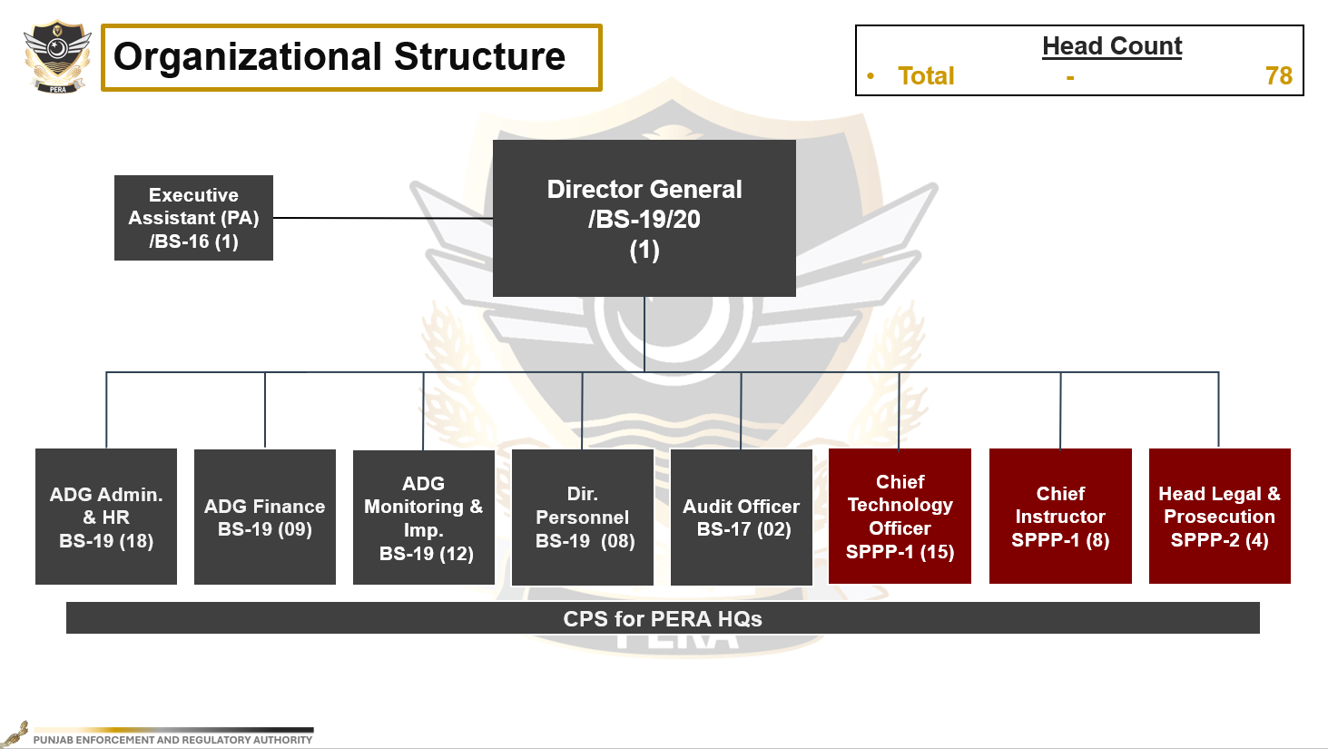
ORGANIZATIONAL STRUCTURE
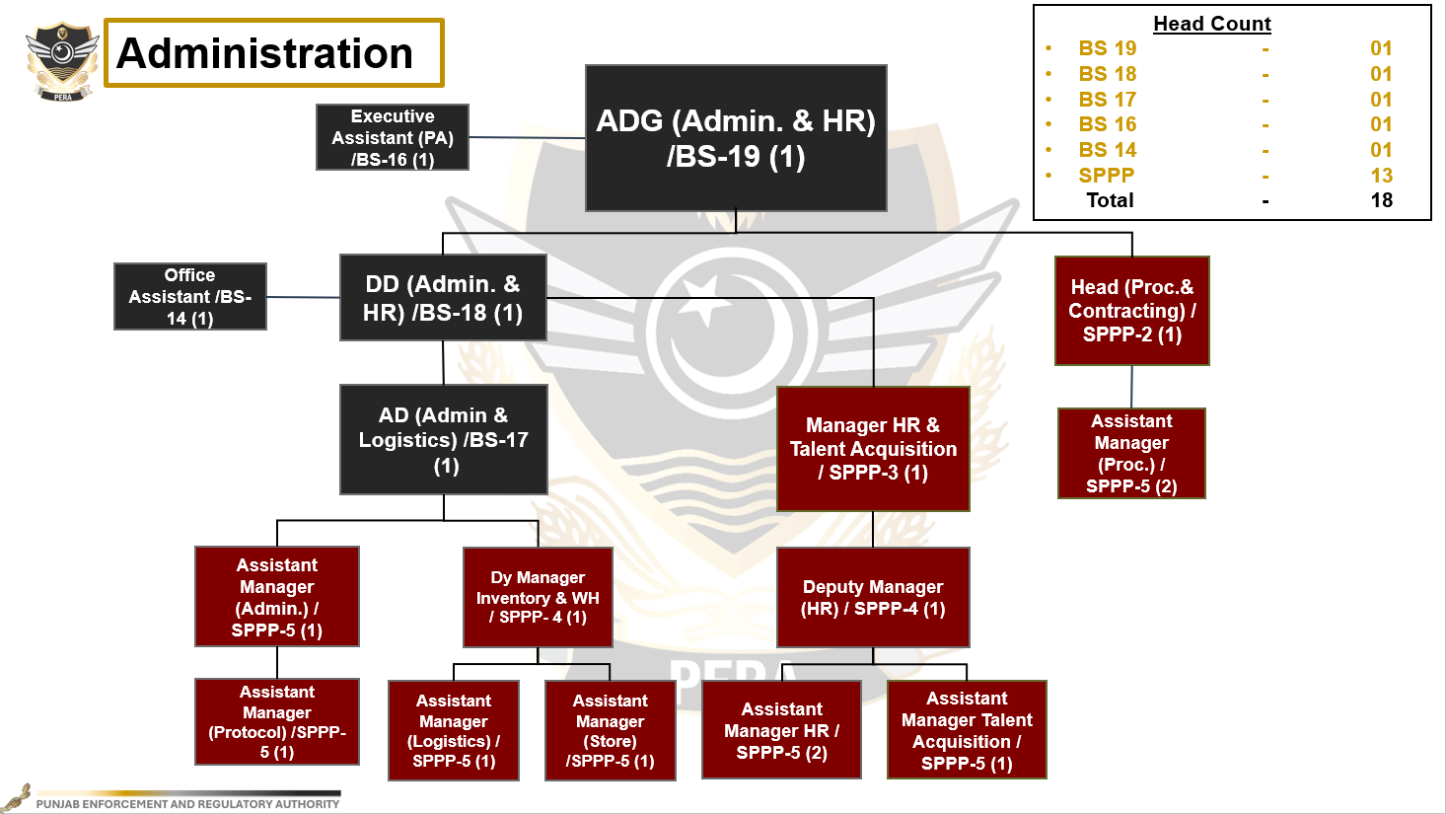

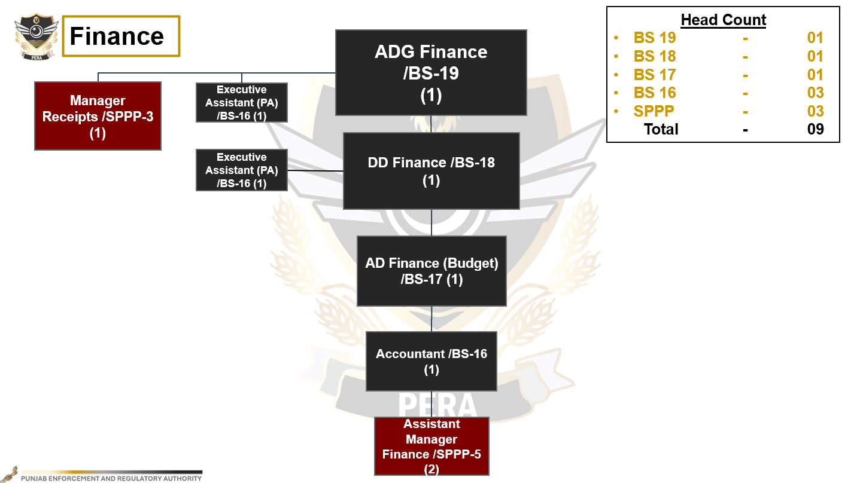

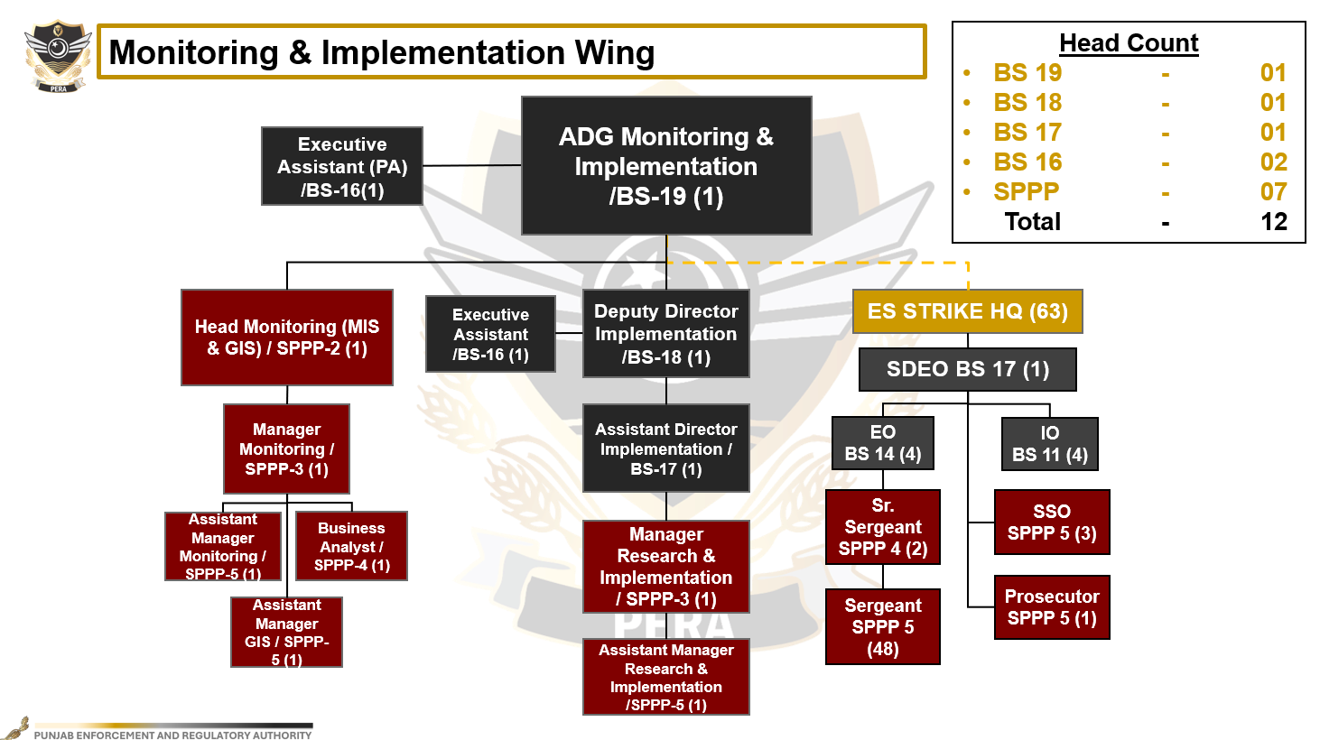

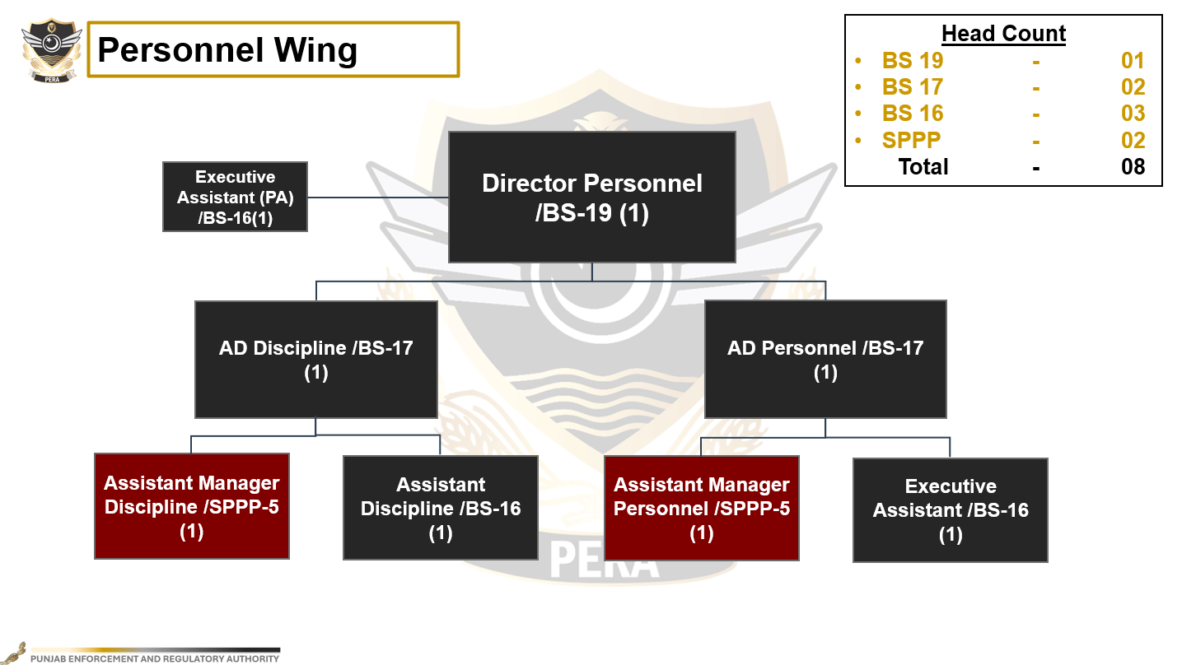

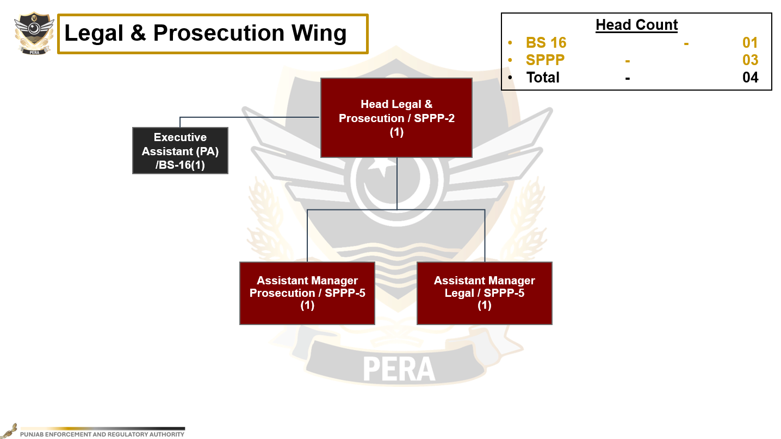

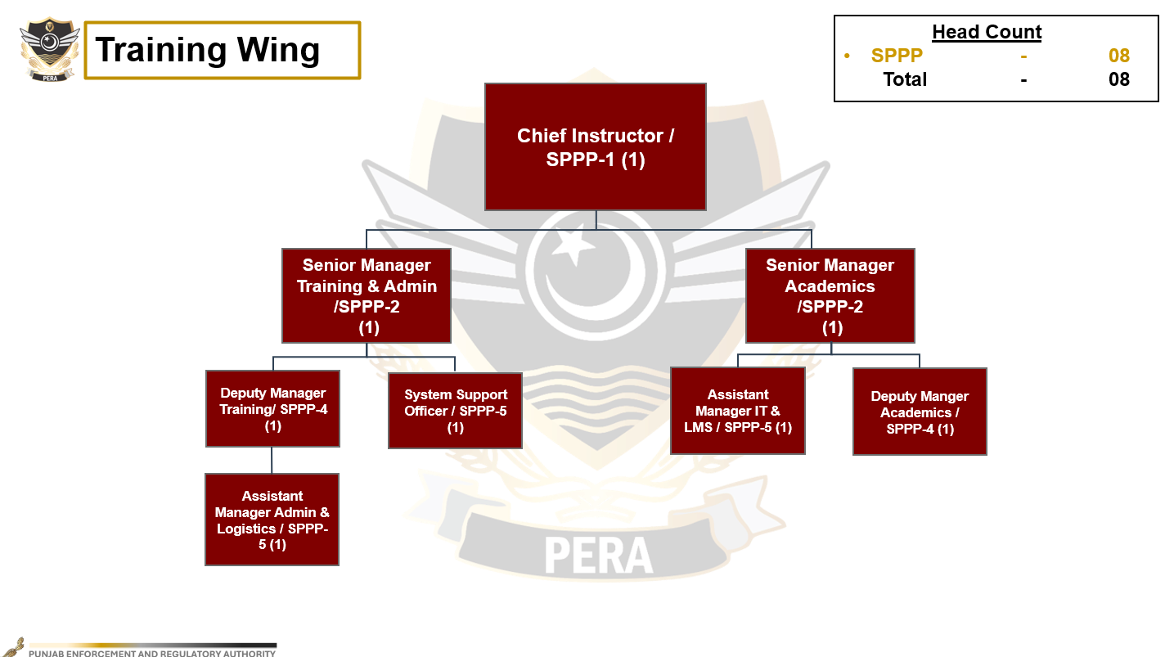

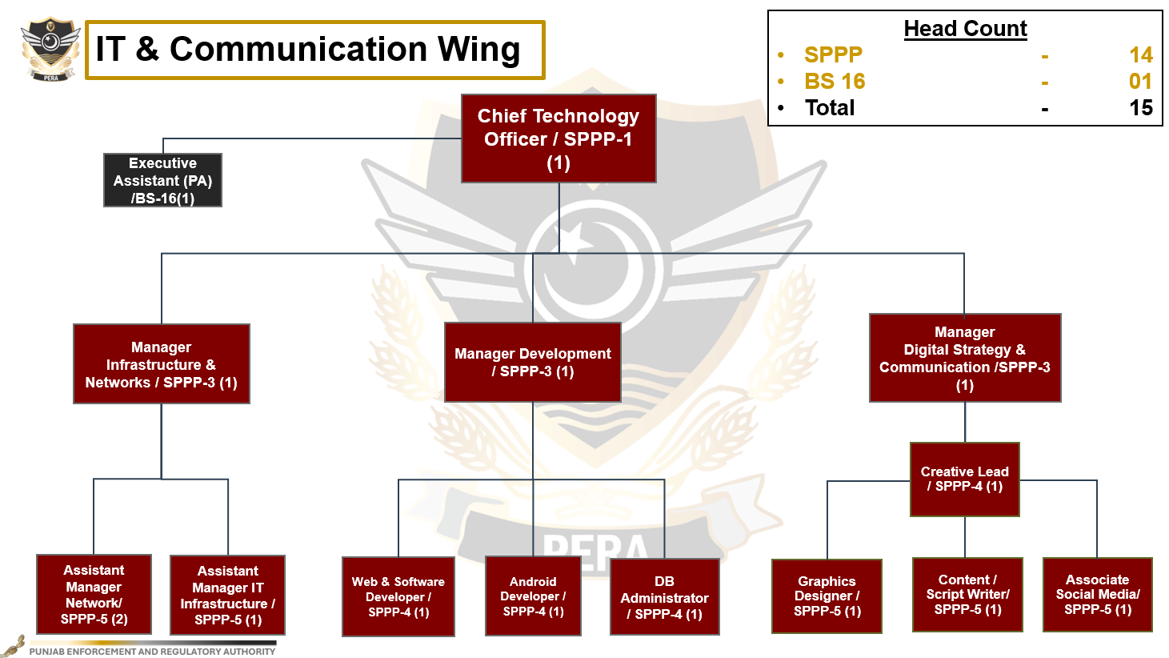

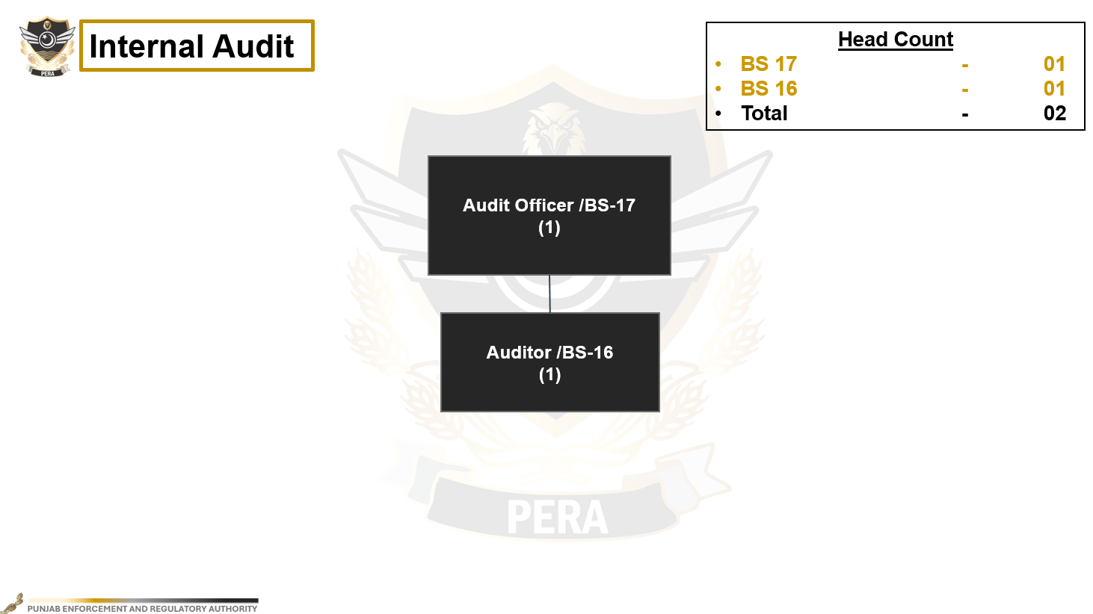

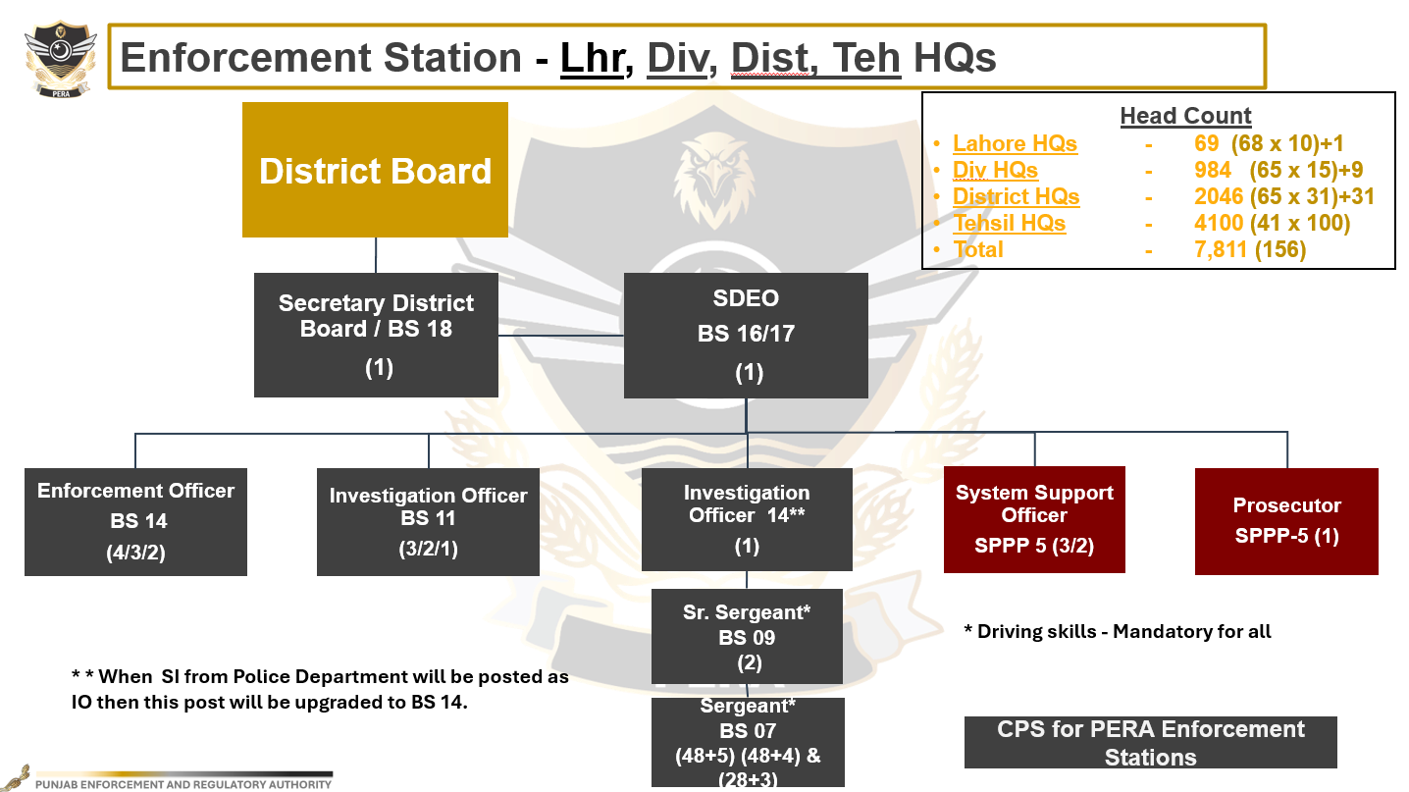
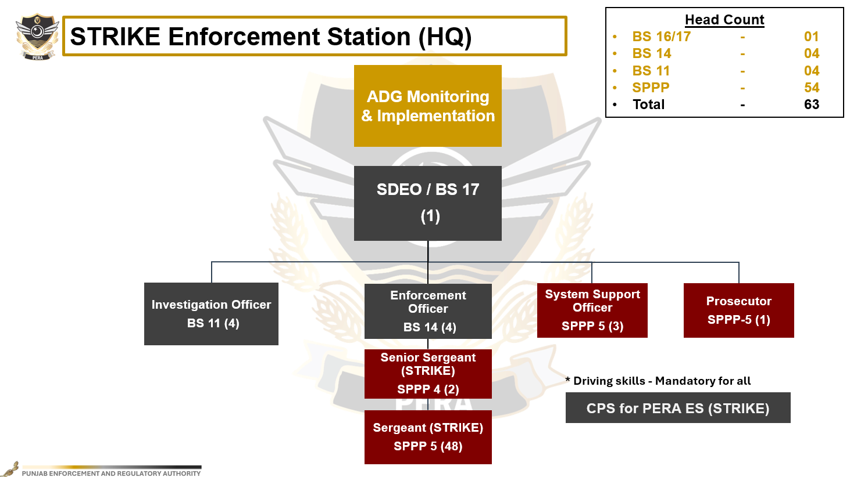

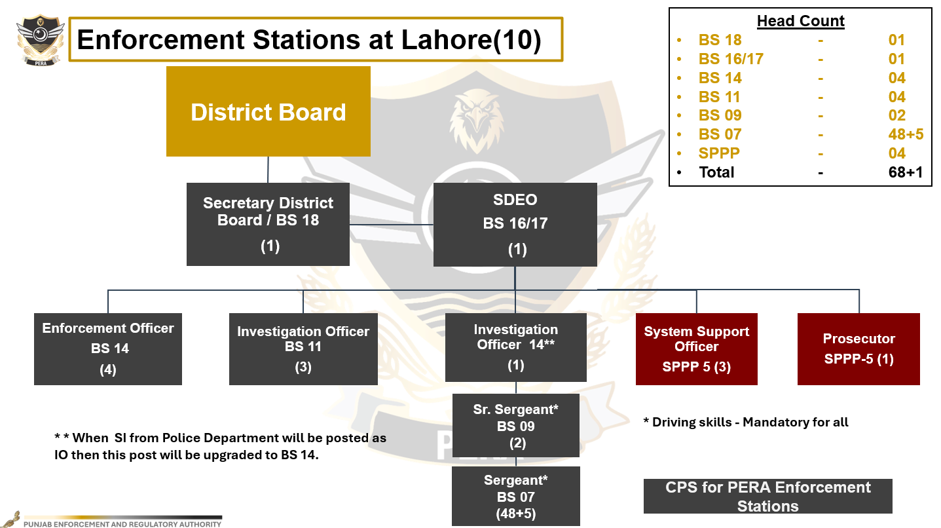
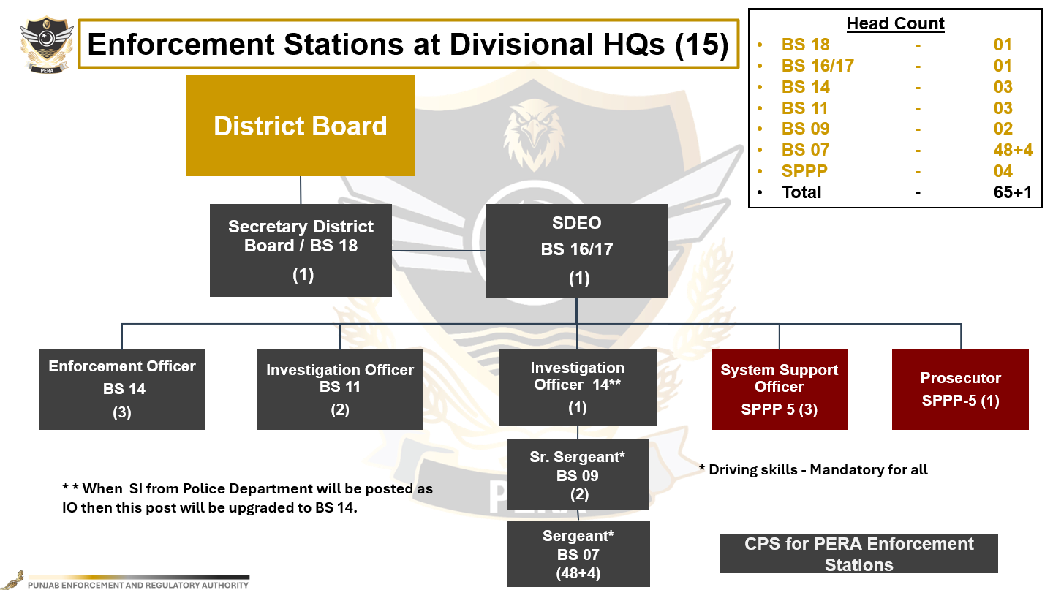

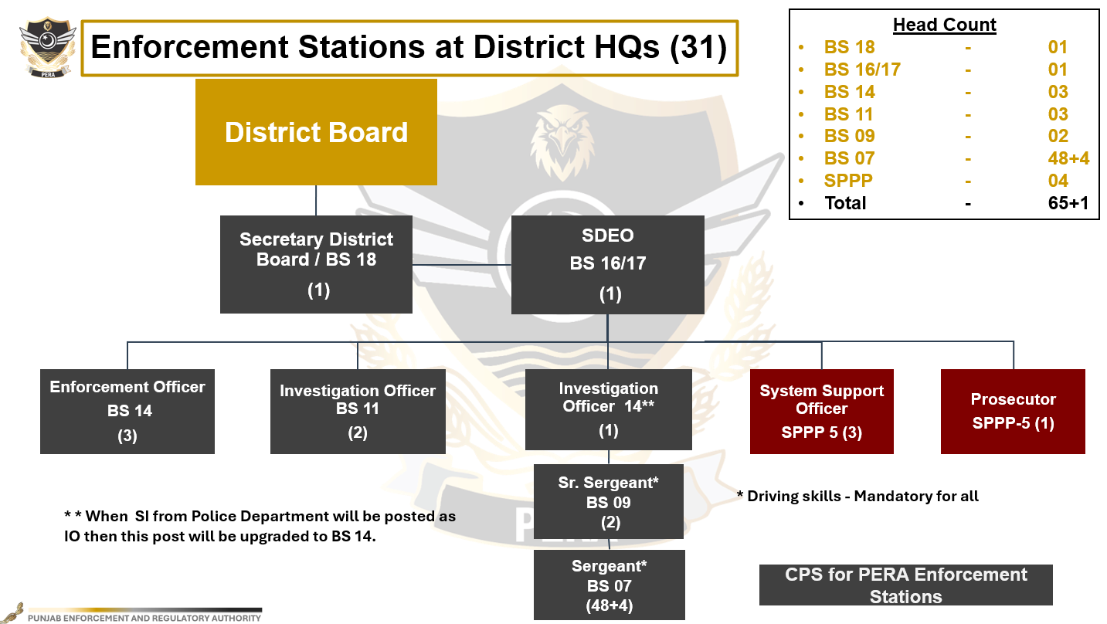

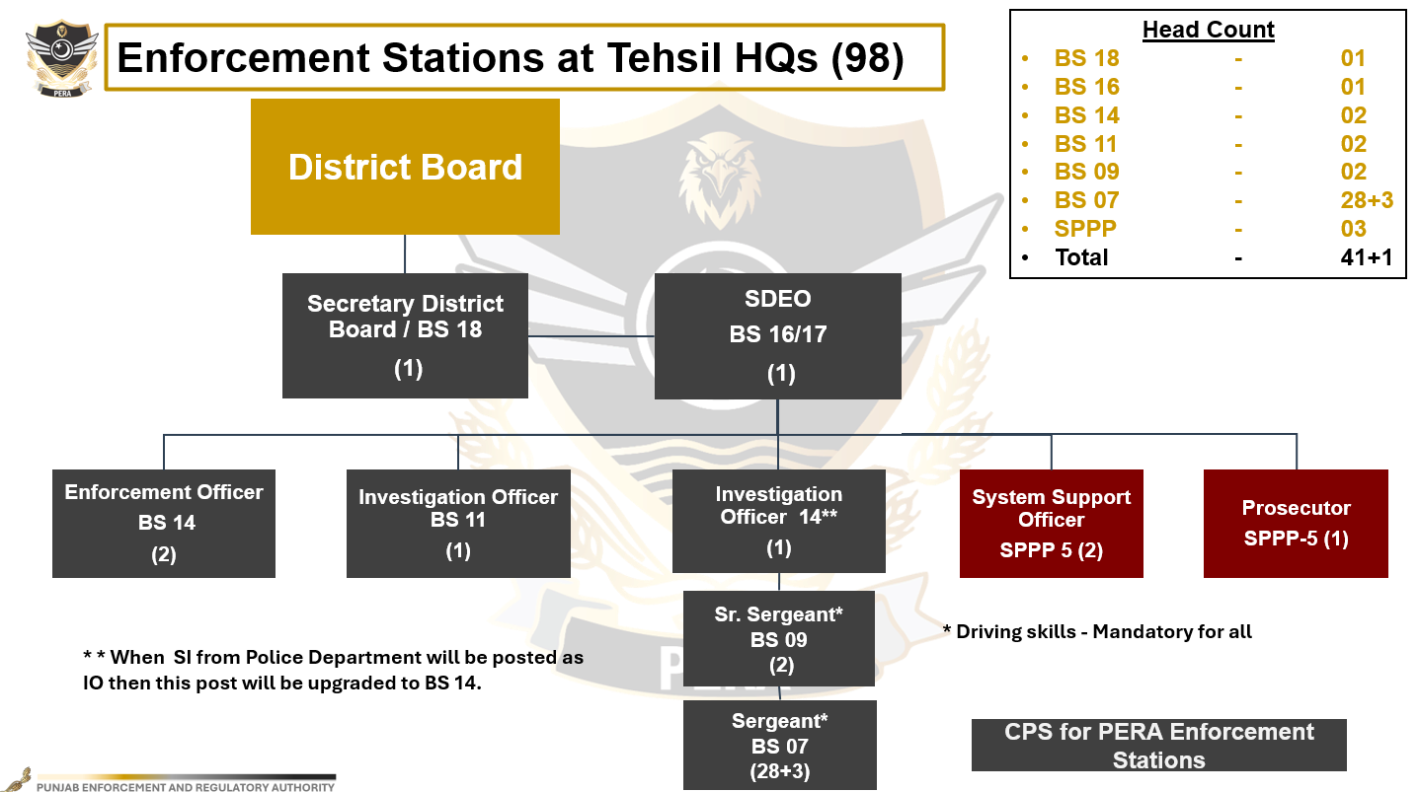

Schedule-II
Terms and Reference for Contractual Employment
Position Title: - Chief Technology Officer (CTO)
Report To: - Director General, PERA
Wing: - IT & Communications
Purpose of the Position:
CTO shall be responsible for providing technical leadership to the team of IT professionals. He shall assist the Director General in ensuring the IT-enabled solutions for all functions of PERA including digitization of processes at the Headquarters and Enforcement Stations level.
Areas of Responsibilities:
- Lead the IT & Communication Wing of PERA and responsible for development, deployment, upgradation, upscaling and troubleshooting of all IT-related technical applications / software products.
- Monitoring deliverables of software development of the projects by managing development lifecycle.
- Responsible for all the activities of the software development team to ensure timely delivery and ensure they adhere to development international standards.
- Monitor changes in the technology sector to discover ways organizations can improve and develop IT Infrastructure.
- Research new technologies to strengthen the organization responsible for technology delivery.
- Provide technical leadership to the team of professionals for Information Technology projects, infrastructure, and data & cyber security to prevent security breaches and keep information confidential.
- Develop, monitor, and enhance an information security management framework.
- Plan and direct the implementation of new IT infrastructure.
- Identify areas and ways through which organization's technological assets can be improved.
- Development & Management of MIS & GIS functions and its monitoring dashboards.
- Ensure smooth electronic communication (connectivity and bandwidth) at multiple Government departments.
Qualification and Experience:
- MS or MPhil. (First Division) in Computer Science, Software Engineering or Information Technology from a recognized University; and
- 10 years’ post qualification experience in the relevant field including at least four years’ experience in public sector.
OR
- Master’s degree or BS (First Division) in Computer Science, Software Engineering, or Information Technology from a recognized University; and
- 12 years’ post qualification experience in the relevant field including at least five years’ experience in public sector.
Note: Experience in private entities shall be accepted if such entity is registered with SECP, Registrar of Firms or any other Public Sector Regulatory Authority.
Competencies & Personal Attributes:
- Strong leadership, team building and problem-solving abilities.
- Inquisitive and detailed oriented with strong analytical skills.
- Excellent communication skills, i.e. written and verbal.
Appointing Authority:
Appointment shall be made by Director General on the recommendations of the Contractual Employment Committee.
Salary and Benefits:
SPPP-1 + any other benefit admissible to SPPP-1 as mentioned in Schedule-III.
Position Title: - Manager (Development)
Report To: - Chief Technology Officer (CTO)
Wing: - IT & Communications
Purpose of the Position:
Responsible for maximizing the productivity / performance of IT Applications / Custom Developed Software / Web Portals by directing the daily, weekly, and monthly activities. To provide leadership, motivation, training, and development of the workforce; process and procedure development to achieve operational excellence.
Areas of Responsibilities:
- To create and document a conceptual and detailed design and write a code based on conceptual description of the business logic.
- To design and development of database components as per requirement of software.
- To compile and write documentation of software development and subsequent revisions inserting comments in the coded instructions.
- To facilitate operational and technical personnel to clarify program intent, identify problems, suggest, and implement changes.
- To assist Business, Operational & Financial teams to define and resolve problems in running software applications/programs as per the software requirement specification.
- To maintain confidentiality with regards to the information being processed, stored, or accessed.
- To test the developed application/component in the UAT/Test environments and deployed on Production.
- Prepares and installs solutions by determining and designing system specifications, standards, and programming.
- Maintenance of the systems once they are up and running.
- Work on Special Projects/Assignments as and when needed by the organization.
- Partner with cross-functional teams (UX, Data, Security) for seamless integration.
- Implement DevOps practices (CI/CD, automation, monitoring).
- Ensure scalability, security, and performance of software solutions.
- Collaborate with Product Management, QA, DevOps, and other stakeholders to align priorities.
- Ensure adherence to Agile/Scrum or other development methodologies.
- Any other duty / assignment assigned by the Sr. Manager.
Qualification and Experience:
- Bachelor’s degree (Hons) in IT, Computer Sciences or Software Engineering or any other relevant / similar degree from a recognized University; and
- 5 years’ post qualification experience in the relevant field including at least four years’ experience in public sector along with 2 years’ experience in Application Development Operations, System Integrations, Business Dashboards, Business Intelligence (ETL to Report Designing), Databases Administration.
Note: Experience in private entities shall be accepted if such entity is registered with SECP, Registrar of Firms or any other Public Sector Regulatory Authority.
Competencies & Personal Attributes:
- Dot Net Core, MVC Entity Framework, SQL Server, Rest API, Angular JS / + AJAX, Bootstrap, Power BI, C#, WCF/REST services, multi-Threading.
- Work on elements of SDLC life cycle (Build, design, development, deployment)
- Experience of Microsoft Azure and other cloud services.
- Experience in writing backend components and Restful APIs.
- Develop technical interfaces, specifications, and architecture.
- Third Party Components Telerik / Dev Express / Crystal Report / RDLC.
- Strong knowledge of API lifecycle management platforms.
- Good command on Microsoft SQL Server stored procedure, views, Functions, database ERP architecture, query optimization.
- Knowledge of technologies like Node JS, React JS, Mongo DB
Appointment:
Appointment shall be made by the Director General on the recommendation of the Contractual Employment Committee.
Salary and Benefits:
SPPP-3 + any other benefit admissible to SPPP-3 as mentioned in Schedule-III.

Position Title: - Manager (Infrastructure & Networks)
Report To: - Chief Technology Officer (CTO)
Wing: - IT & Communication
Purpose of the Position:
Responsible for maximizing the performance of IT infrastructure by directing the daily, weekly, and monthly activities. To provide leadership, motivation, training, and development of the workforce; process and procedure development to achieve operational excellence. Provide event driven operations monitoring, performance tracking and auditing capability.
Areas of Responsibilities:
- Perform various IT Infrastructure Administration tasks including the following areas of responsibility:
- Data Centre Management
- Core Network Infrastructure
- Firewalls, Routers and Switches
- Implement policies and procedures to meet service expectations and quality for Operations users through Firewall/Domain Controller.
- Review the IT infrastructure to meet upcoming needs and expansion plans of the company.
- Monitor network performance and optimize the network for optimal speed and availability.
- Servers Management and their uptime assurance.
- Deploy, configure, and update Domain Controller Group Policies.
- Deploy, configure, and upgrade network software’s, such as enterprise antivirus or other remote support programs.
- Installation of all types of updates like Windows 11, Windows Server 2016/2019/2022, Antivirus and Office 365 & MS Exchange Management.
- Server and Network Equipment Management.
- Plan, coordinate, and implement network security measures to protect IT Infrastructure from Internal/External attacks.
- Responsible for Implementation of Policies, Procedures and SOPs.
- Provide a high level of Technical Support to all Users.
- Vendor Management with Procurement and Finance for their payments.
- Procurement of IT Equipment & Services through Public Tenders with contracts.
- Respond to Trouble tickets raised by Help Desk and is responsible for the resolution.
- All IT Infra & systems administration functions like User Access control, Patch management, Virus Management, Spam Management, etc.
- Coordination with Principals / Vendors on all IT related purchases including laying.
- Manage staff and operations of data center.
Qualification and Experience:
- Bachelor’s degree (Hons) in IT, Computer Sciences, Telecommunication or Software Engineering or any other relevant / similar degree from a recognized university; and
- 5 years’ post qualification relevant experience including at least 3 years’ experience in public sector.
Note: Experience in private entities shall be accepted if such entity is registered with SECP, Registrar of Firms or any other Public Sector Regulatory Authority.
Competencies & Personal Attributes:
- A hands-on management approach that encourages change and creative problem-solving.
- Ability to manage and maintain the operation of the data center and IT Infrastructure.
- Ability to work well in a fast-paced and high-intensity environment.
- Strong knowledge of Key Account Management.
- Strong relationship-building skills.
- Ability to groom.
- Strong planning, execution, monitoring, and administrative skills.
- Good knowledge of market trends of Technology.
- Strong Knowledge of Contract Management
Appointment:
Appointment shall be made by the Director General on the recommendation of Contractual Employment Committee.
Salary and Benefits:
SPPP-3 + any other benefit admissible to SPPP-3 as mentioned in Schedule-III.

Position Title: - Manager (Digital Strategy & Communication)
Report To: - Chief Technology Officer
Wing: - IT & Communication
Purpose of the Position:
To assist Chief Technology Officer in designing and implementing the communication strategy of PERA through electronic, print and social media. To assist DG in making a well-crafted media strategy to ensure advertising and marketing efforts reach the right target audience.

Areas of Responsibilities:
- Will design and implement awareness campaigns related to PERA.
- To devise a launching media strategy for PERA
- Will carry out product designing and marketing for PERA.
- To create awareness among masses regarding PERA’s procedures and scheduled laws
- To highlight PERA’s defined objective to light.
- To utilise various tools including Press conferences, press releases, short films, short documentaries, streamers, and content for all types of media.
- Media management and image building for PERA.
- Any other duties and responsibilities as per the directions of the Competent Authority.
Qualification and Experience:
- Masters in Mass Communication, Marketing, Public Relations, Graphics Designing, Computer Sciences, Advertising, or equivalent from a recognized University.
- Continuous 20-25 years of production career and experience in mainstream TV and social media. Experienced in open and closed-circuit communication and impact. Preferably must have teaching experience in mainstream Universities.
Note: Experience in private entities shall be accepted if such entity is registered with SECP, Registrar of Firms or any other Public Sector Regulatory Authority.
Competencies & Personal Attributes:
- Expert in Ideation and proposal and brand activation.
- Must have knowledge of launching tools.
- Ideation expert in designing campaigns, using various tools.
- Expert in Production Design and campaigns.
- He must be Expert in core production.
- He must have thorough understanding of opinion making and brain washing.
- Possess ample diversified experience in pre and postproduction processes in various genres.
- Expert in communication, persuasion, opinion making and transformation.
- Have ample experience and knowledge of tools of communication and trends on social media.
- He must possess technical knowledge of lighting, camera and postproduction and background scores.
- Must have though understanding of objective of scheduled laws of PERA.
- Must know all Ins and Outs of Production process.
- Must claim to have hands on pulse of Target masses.
- He must have close contact with news and entertainment celebrities and social media influencers.
Appointment:
Appointment shall be made by Director General on the recommendation of Contractual Employment Committee.
Salary and Benefits:
SPPP-3 + any other benefit admissible to SPPP-3 as mentioned in Schedule-III

Position Title: - Assistant Manager (Network)
Report To: - Manager (Infrastructure & Networks)
Wing: - IT & Communication
Purpose of the Position:
Responsible for maximizing the performance of IT Networks and provide, training, and development of the workforce; process and procedure development to achieve operational excellence.
Areas of Responsibilities:
- To assist to perform various IT Network Administration tasks including the following areas of responsibility:
- Data Centre Management
- Core Network Infrastructure
- Firewalls, Routers and Switches
- Implement policies and procedures to meet service expectations and quality for Operations through Firewall/Domain Controller.
- Monitor network performance and optimize the network for optimal speed and availability.
- Servers Management and their uptime assurance.
- Deploy, configure, and update Domain Controller Group Policies.
- Deploy, configure, and upgrade network software’s, such as enterprise antivirus or other remote support programs.
- Installation of all types of updates like Windows 11, Windows Server 2016/2019/2022, Antivirus and Office 365 & MS Exchange Management.
- Server and Network Equipment Management.
- Responsible for Implementation of Policies, Procedures and SOPs.
- Provide a high level of Technical Support to all Users.
- Respond to Trouble tickets raised by Help Desk and is responsible for the resolution.
- All IT Infra & systems administration functions like User Access control, Patch management, Virus Management, Spam Management, etc.
Qualification and Experience:
- Bachelor’s degree (Hons) in IT, Computer Sciences, Telecommunication or Software Engineering or any other relevant / similar degree from a recognized university; and
- 3 years’ post qualification experience in the relevant field including at least two years’ experience in public sector.
Note: Experience in private entities shall be accepted if such entity is registered with SECP, Registrar of Firms or any other Public Sector Regulatory Authority.
Competencies & Personal Attributes:
- A hands-on management approach that encourages change and creative problem-solving.
- Ability to manage and maintain the operation of the data center and IT Networks.
- Ability to work well in a fast-paced and high-intensity environment.
- Strong relationship-building skills.
- Good knowledge of market trends of Technology.
Appointment:
Appointment shall be made by Director General on the recommendation of Contractual Employment Committee.
Salary and Benefits:
SPPP-5 + any other benefit admissible to SPPP-5 as mentioned in Schedule-III

Position Title: - Assistant Manager (IT Infrastructure)
Report To: - Manager (Infrastructure & Networks)
Wing: - IT & Communication
Purpose of the Position:
Responsible for maximizing the performance of IT Networks and provide, training, and development of the workforce; Process and procedure development to achieve operational excellence.
Areas of Responsibilities:
- To assist to perform various IT Network Administration tasks including the following areas of responsibility:
- Data Centre Management
- Core Network Infrastructure
- Firewalls, Routers and Switches
- To implement policies and procedures to meet service expectations and quality for Operations through Firewall/Domain Controller.
- To Monitor network performance and optimize the network for optimal speed and availability.
- Deploy, configure, and upgrade network software, such as enterprise antivirus or other remote support programs.
- Installation of all types of updates like Windows 11, Windows Server 2016/2019/2022, Antivirus and Office 365 & MS Exchange Management.
- Provide a high level of Technical Support to all Users.
- Respond to Trouble tickets raised by Help Desk and is responsible for the resolution.
- All IT network & systems administration functions like User Access control, Patch management, Virus Management, Spam Management, etc.
Qualification and Experience:
- Bachelor’s degree (Hons) in IT, Computer Sciences, Telecommunication or Software Engineering or any other relevant / similar degree from a recognized university; and
- 2 years’ post qualification experience in the relevant field including at least one years’ experience in public sector.
Note: Experience in private entities shall be accepted if such entity is registered with SECP, Registrar of Firms or any other Public Sector Regulatory Authority.
Competencies & Personal Attributes:
- A hands-on management approach that encourages change and creative problem-solving.
- Ability to manage and maintain the operation of the data center and IT Networks.
- Ability to work well in a fast-paced and high-intensity environment.
- Strong relationship-building skills.
- Good knowledge of market trends of Technology.
Appointment:
Appointment shall be made by Director General on the recommendation of Contractual Employment Committee
Salary and Benefits:
SPPP-5 + any other benefit admissible to SPPP-5 as mentioned in Schedule-III

Position Title: - Web & Software Developer
Report To: - Manager (Development)
Wing: - IT & Communication
Purpose of the Position:
He shall design, develop, and maintain web and software applications to meet business and user requirements. This role involves working across front-end, back-end, and full-stack development, ensuring high performance, security, and scalability.
Areas of Responsibilities:
- Experience in Design, Illustrator, Dreamweaver, Photoshop, Figma, Adobe XD etc. Should be well versed in HTML, CSS, Bootstrap, and jQuery.
- Conduct user research and develop business requirement document to understand user needs and preferences. Use this data to inform design decisions.
- Develop and maintain the information architecture of digital products to ensure logical and user-friendly navigation.
- Ensure designs are responsive and accessible across various devices and platforms.
- Ability to be able to form, prototype and confidently present ideas.
- Work with UI/UX designers, product managers, and QA teams.
- Participate in Agile/Scrum processes (sprints, stand-ups, retrospectives).
- Stay updated with emerging technologies and industry trends.
- Work with CI/CD pipelines (GitHub Actions, Jenkins, GitLab CI/CD).
- Deploy applications on cloud platforms (AWS, Azure, GCP).
- Use containerization (Docker, Kubernetes) for scalable deployments.
- Perform unit, integration, and end-to-end testing (Jest, Selenium, Cypress).
- Design and manage databases (SQL: PostgreSQL, MySQL; NoSQL: MongoDB, Firebase).
- Optimize queries and ensure data security and integrity.
- Implement authentication and authorization (OAuth, JWT, SSO).
- Design, develop, and maintain responsive web applications using modern frameworks (React, Angular, Vue.js).
- Build and optimize server-side applications (Node.js, Python, Java, .NET, PHP).
- Develop RESTful APIs and integrate third-party services.
- Ensure cross-browser compatibility, accessibility, and mobile responsiveness.
Qualification and Experience:
- Bachelor’s degree (Hons) in IT, Computer Sciences, or Software Engineering or any other relevant / similar degree from a recognized university; and
- 3 years’ post qualification experience in the relevant field including at least one years’ experience in public sector.
Note: Experience in private entities shall be accepted if such entity is registered with SECP, Registrar of Firms or any other Public Sector Regulatory Authority.
Competencies & Personal Attributes:
- A hands-on management approach that encourages change and creative problem-solving.
- Ability to manage and maintain the operation of the data center and IT Networks.
- Ability to work well in a fast-paced and high-intensity environment.
- Good knowledge of market trends of Technology.
Appointment:
Appointment shall be made by Director General on the recommendation of Contractual Employment Committee.
Salary and Benefits:
SPPP-4 + any other benefit admissible to SPPP-4 as mentioned in Schedule-III
Position Title: - Android Developer
Report To: - Manager (Development)
Wing: - IT & Communication
Purpose of the Position:
The Android Developer designs, develops, and maintains high-performance Android applications. This role involves working with Kotlin/Java, modern Android frameworks, and best practices to create scalable, secure, and user-friendly mobile apps.
Areas of Responsibilities:

- Experience in Design, Illustrator, Dreamweaver, Photoshop, Figma, Adobe XD etc. Should be well versed in HTML, CSS, Bootstrap, and jQuery.
- Conduct usability for android apps, testing to gather feedback and make improvements to designs.
- Ability to be able to form, prototype and confidently present ideas.
- Design and build native Android applications using Kotlin (preferred) or Java.
- Implement Jetpack components (ViewModel, LiveData, Room, Compose).
- Ensure responsive UI/UX with Material Design guidelines.
- Optimize apps for performance, battery efficiency, and memory usage.
- Connect Android apps to RESTful APIs (Retrofit, OkHttp).
- Handle authentication (OAuth, JWT, Firebase Auth).
- Work with real-time data (WebSockets, Firebase Realtime DB).
- Write unit tests & UI tests (JUnit, Espresso, Mockito).
- Debug and fix crashes using Android Studio, Logcat, and Firebase Crashlytics.
- Conduct performance profiling (Android Profiler, Systrace).
- Keep apps updated with the latest Android SDK & security patches.
- Reduce APK size and improve load times.
- Support different screen sizes, OS versions, and devices.
- Work with cross-functional teams (Backend, UX/UI, QA).
- Follow Agile/Scrum methodologies (sprints, code reviews).
- Stay updated with Android trends (Jetpack updates, new APIs).
Qualification and Experience:
- Bachelor’s degree (Hons) in IT, Computer Sciences or Software Engineering or any other relevant / similar degree from a recognized university; and
- 3 years’ post qualification experience in the relevant field including at least one years’ experience in public sector.
Note: Experience in private entities shall be accepted if such entity is registered with SECP, Registrar of Firms or any other Public Sector Regulatory Authority.
Competencies & Personal Attributes:
- A hands-on management approach that encourages change and creative problem-solving.
- Ability to manage and maintain the operation of the data center and IT Networks.
- Ability to work well in a fast-paced and high-intensity environment.
- Strong relationship-building skills.
- Good knowledge of market trends of Technology.
Appointment:
Appointment shall be made by Director General on the recommendations of the Contractual Employment Committee.
Salary and Benefits:
SPPP-4 + any other benefit admissible to SPPP-4 as mentioned in Schedule-III
Position Title: - Database Administrator
Report To: - Manager (Development)
Wing: - IT & Communication
Purpose of the Position:
Responsible for demonstrating database administration, advanced performance analysis and tuning skills. Design and development of database, data warehouse and multi-Dimensional database.
Areas of Responsibilities:
- Design and develop databases, data warehouses and multidimensional databases.
- Design and implement measures, measure groups, granularity, calculated measures, and aggregate functions.
- Implement cubes and implement and configure dimensions in a cube.
- Develop reports using prescriptive analytics and predictive modelling using regression, classification, and clustering techniques.
- Configure authentication and authorization for reporting solution.
- Implement interactivity in reports and configure report data sources and datasets.
- Implementation, Management and Maintenance of SQL database server and other storage devices.
- Performance Monitoring and Tuning of Database Server and other storage devices.
- Routine Maintenance including Log Management and Monitoring.
- Optimization of Storage.
- Establishing standards and schedules for database backups using System Centre Data Protection Manager.
- Recording, developing, and ensuring backups, their schedules and test recovery & restoration procedures for each database.
- Managing Database Users and Security.
- Supporting Development Teams with RDBMS related Issues.
- Perform the role of the principal designer responsible for complex systems and their subsystems employing deep knowledge of current technology and tools, as well as relevant systems that already exist.
- Monitoring performance and managing parameters to provide fast responses to end users.
- Maintain documentation and procedures to ensure adherence to database / data storage / data backup policies, procedures, and regulations.
- Ensure the availability of database backups both onsite and offsite.
- Controlling access permissions and privileges. ETL, moving data, merging data, etc.
- Provide required database management, operations, and support and upgradation capabilities for the IT Department.
- Incorporate changes in database structure by following proper change and experience in data preparation, visualization, analysis, and dashboard development using Tableau/ MS Power BI.
Qualification and Experience:
- Bachelor’s degree (Hons) in IT, Computer Sciences or Software Engineering or any other relevant / similar degree from a recognized university; and
- 3 years’ post qualification experience in the relevant field including at least two years’ experience in public sector.
Note: Experience in private entities shall be accepted if such entity is registered with SECP, Registrar of Firms or any other Public Sector Regulatory Authority.
Competencies & Personal Attributes:
- Experience in SSAS, SSRS and SSIS. Experience TSQL/PLSQL programming.
- Experience in Artificial Intelligence and Machine Learning using Python.
- Experience of MS SQL and MYSQL tuning.
- Knowledge of computing, and Storage systems using System Center Data Protection Manager.
- Experience in data preparation, visualization, analysis, and dashboard development using Tableau/ MS Power BI.
- Strong leadership, team building and problem-solving abilities.
- Inquisitive and detailed oriented with strong analytical skills.
- Excellent communication skills, i.e. written and verbal.
Appointment:
Appointment shall be made by Director General on the recommendations of the Contractual Employment Committee.
Salary and Benefits:
SPPP-4 + any other benefit admissible to SPPP-4 as mentioned in Schedule-III

Position Title: - Creative Lead
Report To: - Manager (Digital Strategy & Communication)
Wing: - IT & Communication
Purpose of the Position:
The Creative Lead is responsible for driving the creative vision, strategy, and execution of all media content and brand communications. They manage a multidisciplinary team of designers, writers, videographers, and digital media professionals to produce high-impact campaigns that align with the organization branding and government expectations. The role combines creative thinking, project management, and leadership skills to deliver compelling narratives across platforms including digital, print, broadcast, and social media.

Areas of Responsibilities:
- Develop and articulate compelling creative concepts for campaigns, branding, and digital media initiatives.
- Ensure a consistent visual and thematic identity across all content.
- Translate business objectives into creative strategies that inspire audiences and achieve results.
- Supervise, mentor, and guide a team of creative professionals including graphic designers, copywriters, and content creators.
- Foster a culture of innovation, collaboration, and continuous improvement.
- Oversee creative workflows and ensure on-time delivery of high-quality content.
- Manage multiple projects from concept through execution, maintaining deadlines and quality control.
- Collaborate with marketing, production, and client servicing teams to align creative outputs with strategic goals.
- Approve storyboards, scripts, visual elements, and final production outputs.
- Present creative proposals and campaign ideas to clients or internal stakeholders.
- Build strong relationships with external creative partners, vendors, and freelancers.
- Stay updated with industry trends in design, digital marketing, video, and technology.
- Introduce new creative tools and platforms to improve output and engagement.
- Develop creative and visually appealing designs for a variety of materials, including brochures, flyers, posters, social media posts, presentations, website elements, and other marketing collateral.
- Collaborate with internal teams to understand design requirements and deliver solutions that meet the communication objectives.
- Stay updated with design trends, tools, and techniques to continuously enhance the quality and relevance of work produced.
- Any other duty and responsibility assigned by the Competent Authority.
Qualification and Experience:
- Bachelor (Hons) / Master Degree in any discipline from an HEC recognized University.

- At least 03 years’ post qualification experience in Production, Graphics Designing, Media Management, Marketing, or any related field.
Competencies & Personal Attributes:
- Proficiency in design software such as Adobe Photoshop, Illustrator, and InDesign.
- Creative thinking with the ability to conceptualize and execute innovative designs.
- Strong attention to detail, ensuring accuracy and visual appeal in all design work.
- Excellent communication skills for collaboration and interpreting design briefs.
- Excellent in maintaining consistent visual identity across various platforms.
- Strong organizational & time management skills to handle multiple projects & meet deadlines.
- Adaptability to new design trends, tools, and techniques.
- Knowledge of print and digital design requirements and file preparation.
- Ability to work collaboratively within a team and provide constructive feedback.
Appointment:
Appointment shall be made by Director General on the recommendations of the Contractual Employment Committee.
Salary and Benefits:
SPPP-4 + any other benefit admissible to SPPP-4 as mentioned in Schedule-III

Position Title: - Graphic Designer
Report To: - Creative Lead
Wing: - IT & Communication
Purpose of the Position:
The Graphic Designer will assist Creative Lead and play a crucial role in enhancing the visual communication of the Punjab Enforcement Regulatory Authority. This position is responsible for creating impactful and effective designs that support the authority's mission, promote its initiatives, and engage the public. The designer will contribute to maintaining a consistent identity across all stakeholders, ensuring that the authority’s visual presence is both professional and accessible. The role also supports the development of creative content for both digital and print platforms, aligning with organizational goals.

Areas of Responsibilities:
- Develop creative and visually appealing designs for a variety of materials, including brochures, flyers, posters, social media posts, presentations, website elements, and other marketing collateral.
- Collaborate with internal teams to understand design requirements and deliver solutions that meet the communication objectives.
- Create layouts and graphics for both digital and print media that are user-friendly, engaging, and aligned with organizational goals.
- Stay updated with design trends, tools, and techniques to continuously enhance the quality and relevance of work produced.
- Edit and prepare final designs, ensuring files are properly formatted for both print and digital publishing.
- Maintain a file management system for all design assets and work with the team to manage deadlines and design requests effectively.
- Provide creative input and contribute to brainstorming sessions for new projects, campaigns, and visual strategies.
- Any other duty and responsibility assigned by the Competent Authority.
Qualification and Experience:
- BS-IT, Fine Arts or equivalent degree from an HEC recognized University.
- At least 02 years’ experience in Graphic Design related field i.e. Adobe Creative (Photoshop, illustrator, InDesign etc.
Note: Experience in private entities shall be accepted if such entity is registered with SECP, Registrar of Firms or any other Public Sector Regulatory Authority.
Competencies & Personal Attributes:
- Proficiency in design software such as Adobe Photoshop, Illustrator, and InDesign.
- Creative thinking with the ability to conceptualize and execute innovative designs.
- Strong attention to detail, ensuring accuracy and visual appeal in all design work.
- Excellent communication skills for collaboration and interpreting design briefs.
- Excellent in maintaining consistent visual identity across various platforms.
- Strong organizational & time management skills to handle multiple projects & meet deadlines.
- Adaptability to new design trends, tools, and techniques.
- Effective problem-solving skills to address design challenges creatively.
- Knowledge of print and digital design requirements and file preparation.
- Ability to work collaboratively within a team and provide constructive feedback.
Appointment:
Appointment shall be made by Director General on the recommendations of the Contractual Employment Committee.
Salary and Benefits:
SPPP-5 + any other benefit admissible to SPPP-5 as mentioned in Schedule-III
Position Title: - Content / Script Writer
Report To: - Creative Lead
Wing: - IT & Communication
Purpose of the Position:
The Content/Script Writer will be responsible for developing clear, engaging, and informative written content for the Punjab Enforcement Regulatory Authority. This includes creating scripts for video content, articles, reports, social media posts, and other communication materials. The goal of the role is to effectively communicate the authority’s key messages, initiatives, and regulatory updates to the public in a compelling, accessible, and professional manner.

Areas of Responsibilities:
- Write clear, concise, and engaging content for various platforms, including websites, social media, videos, reports, and internal documents.
- Develop scripts for video content and media campaigns that effectively communicate the authority’s objectives and regulatory information.
- Research and gather information on relevant topics, ensuring accuracy and relevance in all written materials.
- Collaborate with internal teams to understand project goals, target audiences, and communication needs.
- Ensure all content adheres to the authority’s brand guidelines, tone, and messaging.
- Edit and proofread content to ensure it is error-free, consistent, and meets quality standards.
- Develop content for public awareness campaigns, press releases, and educational material related to regulatory matters.
- Work with the digital team to create optimized content for social media platforms, driving public engagement.
- Monitor the performance of published content and adjust strategies based on audience feedback and analytics.
- Stay updated on industry trends, language usage, and best practices to improve content quality and relevance.
- Any other duty and responsibility assigned by the Competent Authority.
Qualification and Experience:
- Bachelor’s degree in in English / Journalism or equivalent a recognized university.
- At least 01 years’ experience of development of content on various social media platforms.
- Experience of writing articles for known papers/ online sites.
Note: Experience in private entities shall be accepted if such entity is registered with SECP, Registrar of Firms or any other Public Sector Regulatory Authority.
Competencies & Personal Attributes:
- Creativity in presenting complex information in a clear, concise, and engaging manner.
- Experience in writing scripts for video, social media, and other digital content formats.
- Knowledge of SEO best practices for web and social media content optimization.
- Ability to work collaboratively with cross-functional teams to meet content needs.
- Strong organizational skills, with the ability to handle multiple projects and meet deadlines.
- Excellent communication skills for presenting ideas, providing feedback, and collaborating effectively.
- Familiarity with regulatory topics, govt. communication standards or public policy is a plus.
- Ability to adapt writing style to different audiences, platforms, and formats.
Appointment:
Appointment shall be made by the Director General on the recommendations of the Contractual Employment Committee.
Salary and Benefits:
SPPP-5 + any other benefit admissible to SPPP-5 as mentioned in Schedule-III
Position Title: - Associate Social Media
Report To: - Creative Lead
Wing: - IT & Communication
Purpose of the Position:
The Associate social media will be responsible for managing the Punjab Enforcement Regulatory Authority's social media presence, ensuring effective communication and engagement with the public. This role supports the promotion of the authority's initiatives, regulatory updates, and key messages through creative and consistent social media content. The position aims to enhance public awareness and foster positive relationships through digital platforms.

Areas of Responsibilities:
- Manage daily operations of official accounts (e.g., Facebook, Twitter/X, Instagram, YouTube).
- Schedule and publish posts, alerts, advisories, and success stories from field operations or community initiatives.
- Ensure adherence to agency communication policies and government social media guidelines.
- Develop engaging digital content (images, graphics, short videos, infographics) in coordination with the design and field teams.
- Assist in planning and executing awareness campaigns on public safety, legal rights, rules, anti-crime initiatives, etc.
- Promote law enforcement events, community policing programs, and public service announcements.
- Monitor online conversations, mentions, and trends related to the agency and public safety.
- Respond to public queries or complaints with approved messaging protocols and escalate sensitive issues to senior officials.
- Track misinformation or rumors and coordinate corrective digital responses.
- Compile performance metrics (engagement, reach, analysis) for weekly and monthly reports.
- Provide feedback to improve outreach strategies and enhance public trust.
- Maintain a digital archive of published content and key online interactions.
- Liaise with enforcement wings, legal teams, and senior officers for content verification and approvals.
- Coordinate with government PR departments and media units for joint campaigns or press coverage.
Qualification and Experience:
- Mass Communication, Journalism, Public Relations, Media Studies, Language Studies, Social/Administrative Sciences or equivalent degree from an HEC recognized university.
- At least 02 years’ experience in Graphic Design related field i.e. Adobe Creative (Photoshop, illustrator, InDesign etc.
Note: Experience in private entities shall be accepted if such entity is registered with SECP, Registrar of Firms or any other Public Sector Regulatory Authority.
Competencies & Personal Attributes:
- Proficiency in social media management and analytics tools.
- Excellent written and verbal communication skills.
- Ability to adapt tone and messaging for different social media platforms and target audiences.
- Strong creativity in developing content ideas and social media campaigns.
- Knowledge of social media advertising, paid campaigns, and boosting posts.
- Ability to analyze social media performance data and generate insights for improving engagement.
- Familiarity with crisis communication strategies and social media best practices.
Appointment:
Appointment shall be made by Director General on the recommendations of the Contractual Employment Committee.
Salary and Benefits:
SPPP-5 + any other benefit admissible to SPPP-5 as mentioned in Schedule-III
Position Title: - System Support Officer
Report To: - Sub Divisional Enforcement Officer, Concerned Wing Head
Wing: - Enforcement Station, M&I, IT & Communication, Training
Purpose of the Position:
The System Support Officer assist the SDEO with the various functions at Enforcement Stations. including providing comprehensive technical and administrative support to ensure smooth operations and functioning of IT infrastructure as well as office administration. The role involves addressing hardware, software, and network-related issues while also handling clerical and administrative tasks such as duty roster management, correspondence, financial record-keeping, and vendor coordination.

Areas of Responsibilities:
- Manage and troubleshoot hardware components including desktops, laptops, printers, scanners, and other peripheral devices.
- Install, configure, and maintain software applications in accordance with PERA’s requirements.
- Monitor, manage, and resolve network connectivity issues, ensuring minimal downtime.
- Coordinate with external IT support providers and vendors for specialized technical assistance when required.
- Maintain records of hardware and software inventory.
- Prepare and manage the duty roster for PERA’s personnel, ensuring appropriate coverage.
- Draft, manage, and dispatch official correspondence to the Head Office and other external/internal departments.
- Maintain systematic filing of official records, memos, and correspondence.
- Maintain financial records related to office expenses, vendor payments, and operational budgets.
- Process vendor bills and ensure timely payment in compliance with agency procedures.
- Manage office supplies inventory and coordinate procurement to maintain adequate stock levels.
- Coordinate with vendors for hardware, software, and network maintenance services.
- Liaise with internal teams and external departments to ensure seamless operations.
- Prepare periodic reports on IT system status, administrative activities, and financial expenditures for management review.
- Responsible for software and hardware configuration, update and design for increased efficiency of the systems.
- Maintain IT and office records (contracts, warranties, service agreements).
- Drafting noting & letters as per the requirements of SDEOs.
- Liaise with landlords, vendors, and service providers (electricity, internet, maintenance).
- Manage courier services, mail distribution, and petty cash reconciliations.
- Manage all matters related to Admin, Finance, Procurement & enforcement stations.
Qualification and Experience:
- 16 years’ education, preferably in Computer Science / Information Technology / Software Engineering or any related discipline.
- 2 years of IT interventions, Implementation, Networking or Software Development experience in reputable organization(s).
Note: Experience in private entities shall be accepted if such entity is registered with SECP, Registrar of Firms or any other Public Sector Regulatory Authority.
Competencies & Personal Attributes:
- Good written and verbal communication skills.
- Understanding of financial & Admin matters.
- Communication Skills.
- Analytical skills.
- Presentation skills.
- Must be proficient in the use of IT and MS Office
- Noting / drafting skills
Appointment:
Appointment shall be made by Director General on the recommendations of the Contractual Employment Committee.
Salary and Benefits:
SPPP-5 + any other benefit admissible to SPPP-5 as mentioned in Schedule-III

Position Title: - Head (Procurement & Contracting)
Report To: - ADG (Admin & HR)
Wing: - Administration & HR
Purpose of the Position:
Responsible for ensuring that procurement & contracting activities are managed effectively and efficiently for the smooth working of the supply chain of the Authority. Also, responsible for developing and implementing policies, procedures, and objectives for managing and controlling the procurement function in line with the authority objectives.
Areas of Responsibilities:
- Manage the operations of Procurement & Contracting to ensure the smooth supply chain of the Authority.
- Develop and maintain a high-performance culture in the procurement resulting in continued success in meeting functional KPIs.
- Ensure implementation and compliance of the Procurement Policy and maintaining the transparency & integrity of procurement process.
- Ensure that Goods, Services, Works, and Consultancy Services are procured from reliable & quality vendors and at best value in compliance with PPRA Rules.
- Overall responsibility for the timely processing of requisitions, purchase orders and vendor invoices with focus on continuous improvements.
- Liaise with counterparts in other wings to ensure alignment of activities and objectives.
- Carrying out periodical analysis and reviews for cost control/reduction/rationalization as well as benchmarking with best practices in various activities.
- Identification and implementation of process improvements to increase efficiency and accuracy.
- Assisting/managing internal & external audits retaliated to procurement.
- Manage work allocation, training, problem resolution, performance assessment of the procurement team.
- Any other duties and responsibilities as assigned by the Competent Authority.
Qualification and Experience:
- BS/BSc/Master’s degree in Supply Chain Management, Business Administration or equivalent (16 years education) from an HEC recognized University.
- 10 years of procurement management experience in reputable organization(s) and having more than 5 years’ experience in public sector procurement.
Note: Experience in private entities shall be accepted if such entity is registered with SECP, Registrar of Firms or any other Public Sector Regulatory Authority.
Competencies & Personal Attributes:
- Extensive Knowledge of PPRA rules & regulations and Contract Management.
- Knowledge of ERP implementation
- Strong leadership, team building and problem-solving abilities.
- Negotiation and interpersonal skills
- Inquisitive and detail-oriented with strong analytical skills
- Excellent communication skills, i.e. written and verbal.
Appointment:
Appointment shall be made by Director General on the recommendations of the Contractual Employment Committee.
Salary and Benefits:
SPPP-2 + any other benefit admissible to SPPP-2 as mentioned in Schedule-III
Position Title: - Manager (HR & Talent Acquisition)
Report To: - Deputy Director (Admin. & HR)
Wing: - Administration & HR
Purpose of the Position:
The Manager (HR & Talent Acquisition) Specialist supports the Deputy Director Administration & HR in the execution of talent acquisition and organizational development functions. Key responsibilities include assisting with recruitment and onboarding, driving talent management initiatives, organizational development programs, and supporting HR operations to enhance workforce capability and employee engagement.
Areas of Responsibilities:
- Manage the recruitment and onboarding process for new hires, ensuring timely completion of documentation, interviews, and induction formalities.
- Support the Director Administration & HR in managing and updating recruitment records, candidate databases, and talent pipelines.
- Manage administrative support in day-to-day talent acquisition activities such as job postings, screening resumes, coordinating interviews, and liaising with recruitment agencies.
- Plan organizational development initiatives including training needs analysis, employee development programs, and succession planning.
- Coordinate with departments to align recruitment strategies with organizational goals and workforce planning.
- Maintain confidentiality of candidate and employee data and ensure adherence to organizational policies and legal requirements in recruitment and development processes.
- Plan, organize, and execute employee engagement activities, team-building sessions, and cultural initiatives.
- Assist in drafting and updating policies, procedures, and manuals related to talent acquisition and organizational development.
- Respond to queries related to recruitment processes and employee development initiatives and escalate complex matters to Director Administration & HR.
- Perform any other related tasks assigned by the Director Administration & HR or competent authority.
- Perform any other duties assigned by the competent authority.
Qualification and Experience:
- BS/BSc/Master’s degree in Human Resource Management, Business Administration, Public Administration, Management Sciences or equivalent (16 years’ education) from a recognized university.
- At least 8 years of relevant experience required.
Note: Experience in private entities shall be accepted if such entity is registered with SECP, Registrar of Firms or any other Public Sector Regulatory Authority.
Competencies & Personal Attributes:
- Strong presentation, report writing, and interpersonal skills.
- In-depth knowledge of talent acquisition strategies, recruitment best practices, and organizational development methods.
- Proficient understanding of HR policies, labor laws, and modern HR technologies related to recruitment and development.
- Proficient in the use of Microsoft Office
- Integrity, empathy, and ability to handle confidential information sensitively.
Appointment:
Appointment shall be made by Director General on the recommendations of the Contractual Employment Committee.
Salary and Benefits:
SPPP-3 + any other benefit admissible to SPPP-3 as mentioned in Schedule-III
Position Title: - Deputy Manager (HR)
Report To: - Manager (HR & Talent Acquisition)
Wing: - Administration & HR
Purpose of the Position:
The Deputy Manager – Human Resources plays a critical role in supporting the Manager (HR & Talent Acquisition) in executing core HR functions. This includes recruitment, employee relations, performance management, regulatory compliance, and day-to-day HR operations. The incumbent contributes to the effective implementation of HR policies, fosters a positive organizational culture, and supports strategic HR initiatives to enhance employee engagement and organizational efficiency.
Areas of Responsibilities:
- Assist in managing the recruitment process including job postings, screening, interviews, and offer rollouts.
- Maintain employee personnel files and ensure timely onboarding.
- Support implementation of attendance management systems and generate daily and monthly attendance reports.
- Maintain accurate records of leave, time-offs, and payroll inputs.
- Update and maintain the Human Resource Information Management System (HRMIS).
- Assist in identifying training needs and preparing learning and development (L&D) plans.
- Coordinate capacity-building programs and monitor participation and outcomes.
- Support the implementation and oversight of the pay structure and employee benefits program.
- Address employee grievances, and disciplinary issues in line with organizational policies.
- Conduct exit interviews and analyze turnover trends for corrective actions.
- Organize employee engagement initiatives such as team building and recognition events.
- Assist in implementing performance appraisal systems (e.g., KPIs/OKRs).
- Track performance data, maintain feedback records, and support employee development plans.
- Ensure compliance with applicable labor laws and internal HR policies.
- Assist in reviewing and updating HR policies, manuals, and SOPs.
- Prepare periodic HR reports including attrition analysis, hiring metrics etc.
- Perform any other duties assigned by the competent authority.
Qualification and Experience:
- BS/BSc/Master’s degree in Business Administration, Human Resource Management or equivalent (16 years education) from an HEC recognized University; and
- 3 years’ post qualification experience in the relevant field including at least two years’ experience in public sector.
Note: Experience in private entities shall be accepted if such entity is registered with SECP, Registrar of Firms or any other Public Sector Regulatory Authority.
Competencies & Personal Attributes:
- Presentation skills and report writing.
- Strong understanding of HR policies, labor laws, and modern HR practices.
- Must possess thorough understanding of procedures related to contractual appointments.
- Should have proficiency in the use of IT.
- Integrity and empathy
- Conflict management skills
Appointment:
Appointment shall be made by Director General on the recommendations of the Contractual Employment Committee.
Salary and Benefits:
SPPP-4 + any other benefit admissible to SPPP-4 as mentioned in Schedule-III
Position Title: - Deputy Manager (Inventory & Warehousing)
Report To: - Assistant Director (Admin & Logistics)
Wing: - Administration & HR
Purpose of the Position:

The Deputy Manager (Inventory & Warehousing) supports the Assistant Director (Admin & Logistics) in ensuring that all inventory and warehousing operations are carried out efficiently, systematically, and in compliance with established SOPs. The role focuses on maintaining accuracy, reliability, and organization in inventory management processes.
Areas of Responsibilities:
- Plan and implement efficient supply chain and inventory management strategies.
- Ensure timely distribution of inventory while maintaining minimum stock levels and service quality standards.
- Maintain warehouse facilities in compliance with safety standards and operational SOPs.
- Monitor and control inventory to ensure accurate stock levels and minimize discrepancies.
- Research, evaluate, and recommend cost-effective inventory and storage solutions.
- Ensure completeness and accuracy of documentation as per policies and procedures.
- Identify and report any discrepancies between physical stock and inventory records.
- Maintain comprehensive and audit-ready inventory records.
- Ensure continuous updates and functionality of the Inventory Management System (IMS).
- Compile reports on inventory balances, pricing, and cost trends.
- Develop and enforce inventory control policies and procedures.
- Forecast demand and inform relevant person regarding inventory replenishment to maintain optimal stock levels.
- Conduct regular cycle counts and annual physical audits to verify stock accuracy.
- Analyze inventory data to identify gaps and initiate corrective measures.
- Minimize obsolete and slow-moving stock through proactive stock management.
- Perform any other task assigned by senior management.
Qualification and Experience:
- BS/BSc/Master’s degree in Business Administration, Management Science, Supply Chain Management, or equivalent (16 years’ education) from a recognized university; and
- 3 years’ post qualification relevant experience including at least two years’ experience in public sector.
Note: Experience in private entities shall be accepted if such entity is registered with SECP, Registrar of Firms or any other Regulatory Authority.
Competencies & Personal Attributes:
- Strong understanding of inventory and warehousing operations
- Proficiency in MS Office and inventory management systems
- Sharp analytical and problem-solving skills
- Attention to detail and commitment to accuracy and compliance.
- Effective communication and coordination abilities
Appointment:
Appointment shall be made by Director General on the recommendation of Contractual Employment Committee-I.
Salary and Benefits:
SPPP-4 Pay Scale + any other benefit admissible to SPPP-4 as mentioned in Schedule-III

Position Title: - Assistant Manager (Logistics)
Report To: - Deputy Manager (Inventory & Warehousing)
Wing: - Administration & HR
Purpose of the Position:

The Assistant Manager Logistics assists the Assistant Director Logistics & Inventory in managing day-to-day logistics operations. The role involves planning, coordinating, and monitoring the movement of goods and materials to ensure timely and cost-effective delivery. Responsibilities include overseeing transportation, managing vendor relationships, and ensuring compliance with PERA policies.

Areas of Responsibilities:
- Track vehicle usage, mileage, fuel consumption, and driver assignments.
- Ensure vehicles are mission-ready through preventive maintenance and timely servicing.
- Maintain vehicle logs and reports for operational transparency and audits.
- Plan and oversee the movement of equipment, supplies, and personnel for training, field operations, or official deployments.
- Coordinate the distribution and inventory of logistics items including fuel, protective gear, communication devices, and operational kits.
- Coordinate with technical teams and approved vendors for vehicle repairs, maintenance, spare parts, and inspections.
- Assist in drafting vehicle and logistics procurement requests, specifications, and bid evaluations in accordance with public procurement rules.
- Monitor fleet insurance, registration, and compliance with traffic and vehicle safety regulations.
- Ensure compliance with internal fleet policies and national transportation laws.
- Maintain updated records on all assets, including ownership documents, insurance, maintenance logs, and accident reports.
- Prepare periodic reports on fleet performance, cost-efficiency, and logistics activities for senior management.
- Manage the POL of authorized vehicles and Officials.
Qualification and Experience:
- BS/BSc/Master’s degree in Business Administration, Management Sciences, Logistics, Supply Chain Management or equivalent (16 years’ education) from a recognized university; and
- 2 years’ post qualification relevant experience including at least one-year experience in public sector.
Note: Experience in private entities shall be accepted if such entity is registered with SECP, Registrar of Firms or any other Regulatory Authority.
Competencies & Personal Attributes:
- Ability to assess logistical processes, identify bottlenecks, and propose solutions.
- Proficient in Microsoft Office and logistics software.
- Competent in accurate notetaking and drafting professional documents.
- Ability to troubleshoot and resolve issues efficiently.
- Excellent verbal and written communication.
Appointment:
Appointment shall be made by Director General on the recommendation of Contractual Employment Committee-I.
Salary and Benefits:
SPPP-5 Pay Scale + any other benefit admissible to SPPP-5 as mentioned in Schedule-III

Position Title: - Assistant Manager (Stores)
Report To: - Deputy Manager (Inventory & Warehousing)
Wing: - Administration & HR
Purpose of the Position:

The Assistant Manager (Stores) assists the Deputy Manager (Inventory & Warehousing) in managing daily store operations. The role involves maintaining stock accuracy, ensuring smooth inward and outward movement of inventory, and implementing storekeeping procedures in line with organizational policies. Responsibilities include record management, storage optimization, stock issuance, and supporting audit and compliance functions.
Areas of Responsibilities:
- Monitor day-to-day store operations and ensure accurate stock entries in the inventory system.
- Receive, inspect, and verify incoming goods as per specifications and documentation.
- Ensure systematic storage, labeling, and categorization of stock to optimize space and access.
- Issue inventory as per authorized requisitions and maintain proper records.
- Conduct routine physical stock counts and reconcile with inventory records.
- Maintain records of damaged, expired, or returned items and report discrepancies.
- Assist in the preparation of demand forecasts and reorder levels to avoid stockouts.
- Ensure cleanliness, safety, and security of the store area in compliance with health and safety standards.
- Support internal and external audit exercises by providing accurate documentation.
- Prepare regular inventory status reports for senior management.
- Ensure compliance with PERA policies and standard operating procedures.
Qualification and Experience:
i BS/BSc/Master’s degree in Business Administration, Management Sciences, Supply Chain Management, or equivalent (16 years education) from a recognized university; and
ii 2 years’ post qualification relevant experience including at least one year experience in public sector.
Note: Experience in private entities shall be accepted if such entity is registered with SECP, Registrar of Firms or any other Regulatory Authority.
Competencies & Personal Attributes:
- Knowledge of storekeeping practices, stock control, and record management.
- Proficient in Microsoft Office and inventory management software.
- Strong attention to detail and documentation accuracy.
- Effective communication and coordination skills.
- Ability to manage time and multiple tasks efficiently.
Appointment:
Appointment shall be made by Director General on the recommendation of Contractual Employment Committee-I.
Salary and Benefits:
SPPP-5 Pay Scale + any other benefit admissible to SPPP-5 as mentioned in Schedule-III

Position Title: - Assistant Manager (HR)
Report To: - Deputy Manager (HR & Talent Acquisition)
Wing: - Administration & HR
Purpose of the Position:

The Assistant Manager (HR) supports the Deputy Manager (HR & Talent Acquisition) in the execution of day-to-day HR functions. Key responsibilities include assisting with employee onboarding and orientation, maintaining HR records, and supporting general HR operations to ensure smooth administrative processes and a positive employee experience.

Areas of Responsibilities:
- Assist in the onboarding and orientation process for new employees, ensuring timely completion of documentation and induction formalities.
- Support the Deputy Manager – HR in maintaining and updating employee records, including personal files, attendance, and leave data.
- Provide administrative support in day-to-day HR functions such as preparing letters, maintaining trackers, and updating HR databases.
- Coordinate with relevant departments to facilitate employee requests related to HR services.
- Assist in organizing employee events and engagement activities.
- Maintain confidentiality of employee information and ensure adherence to HR policies and procedures.
- Support the implementation of HR systems and digital recordkeeping tools.
- Assist in drafting and updating HR-related documents, including templates, forms, and policy manuals.
- Respond to employee queries regarding HR procedures and escalate complex issues to the Deputy Manager – HR.
- Perform any other tasks assigned by the Deputy Manager – HR or competent authority.
Qualification and Experience:
- BS/BSc/Master’s degree in Business Administration in Human Resource Management or equivalent (16 years’ education) from a recognized university; and
- 2 years’ post qualification relevant experience including at least one-year experience in public sector.
Note: Experience in private entities shall be accepted if such entity is registered with SECP, Registrar of Firms or any other Regulatory Authority.
Competencies & Personal Attributes:
- Presentation skills and report writing.
- Strong understanding of HR policies, labor laws, and modern HR practices.
- Must possess thorough understanding of procedures related to contractual appointments.
- Should have proficiency in the use of IT.
- Integrity and empathy
- Conflict management skills
- Excellent communication skills, i.e. written and verbal.
Appointment:
Appointment shall be made by Director General on the recommendation of Contractual Employment Committee-I.
Salary and Benefits:
SPPP-5 Pay Scale + any other benefit admissible to SPPP-5 as mentioned in Schedule-III

Position Title: - Assistant Manager (Talent Acquisition)
Report To: - Deputy Manager (HR & Talent Acquisition)
Wing: - Administration & HR
Purpose of the Position:

The Assistant Manager (Talent Acquisition) supports the Deputy Manager (HR & Talent Acquisition) in the execution of talent acquisition and organizational development functions. Key responsibilities include assisting with recruitment and onboarding, driving talent management initiatives, organizational development programs, and supporting HR operations to enhance workforce capability and employee engagement.
Areas of Responsibilities:
- Assist the recruitment and onboarding process for new hires, ensuring timely completion of documentation, interviews, and induction formalities.
- Support the Manager Talent Acquisition in managing and updating recruitment records, candidate databases, and talent pipelines.
- Provide administrative support in day-to-day talent acquisition activities such as job postings, screening resumes, coordinating interviews, and liaising with recruitment agencies.
- Support organizational development initiatives including training needs analysis, employee development programs, and succession planning.
- Coordinate with departments to align recruitment strategies with organizational goals and workforce planning.
- Maintain confidentiality of candidate and employee data and ensure adherence to organizational policies and legal requirements in recruitment and development processes.
- Assist in planning, organizing, and executing employee engagement activities, team-building sessions, and cultural initiatives.
- Assist in drafting and updating policies, procedures, and manuals related to talent acquisition and organizational development.
- Respond to queries related to recruitment processes and employee development initiatives and escalate complex matters to Talent Acquisition Specialist.
- Perform any other related tasks assigned by the Manager Talent Acquisition or competent authority.
Qualification and Experience:
- BS/BSc/Master’s degree in Human Resource Management, Business Administration, Public Administration, Management Sciences (Admin or Finance) (16 years’ education) from a recognized university.
- At least 2 years of relevant experience required.
Note: Experience in private entities shall be accepted if such entity is registered with SECP, Registrar of Firms or any other Regulatory Authority.
Competencies & Personal Attributes:
- Strong presentation, report writing, and interpersonal skills.
- In-depth knowledge of talent acquisition strategies, recruitment best practices, and organizational development methods.
- Proficient understanding of HR policies, labor laws, and modern HR technologies related to recruitment and development.
- Proficient in the use of Microsoft Office
- Integrity, empathy, and ability to handle confidential information sensitively.
Appointment:
Appointment shall be made by Director General on the recommendation of Contractual Employment Committee-I.
Salary and Benefits:
SPPP-5 Pay Scale + any other benefit admissible to SPPP-5 as mentioned in Schedule-III
Position Title: - Assistant Manager (Admin.)
Report To: - Assistant Director (Admin. & Logistics)
Wing: - Administration & HR
Purpose of the Position:

The Assistant Manager Admin is responsible for ensuring the efficient functioning of daily office operations. This includes managing facilities, handling documentation, and coordinating support services. The role requires strong organizational skills, the ability to multitask effectively, and a proactive approach to maintaining a smooth and efficient workplace environment.

Areas of Responsibilities:
- Oversee and manage the day-to-day office operations, including facility maintenance, cleanliness, and office supplies.
- Ensure the proper functioning of office equipment (printers, scanners, IT assets) and coordinate necessary repairs or replacements.
- Supervise and coordinate external services, like security and housekeeping to ensure seamless support for employees.
- Manage office space utilization, seating arrangements, and workspace allocation.
- Support employees in workstation setup, access cards, and related logistics.
- Organize and coordinate internal and external events, meetings, and conferences, ensuring smooth execution.
- Handle visitor management and coordinating meetings.
- Ensure compliance with workplace safety standards, including conducting fire drills and maintaining first aid kits.
- Ensure proper documentation and maintenance of office records, leases, permits, and insurance policies.
- Monitor and validate third-party service providers’ performance, ensuring the quality and cost-effectiveness of services rendered.
- Analyze office administration processes and provide insights for continuous improvement.
- Prepare and present administrative reports and key metrics to senior management.
- Collaborate with cross-functional teams to improve operational efficiency and service delivery.
- Perform any other duties or tasks assigned by the competent authority.
Qualification and Experience:
- BS/BSc/Master’s degree in Business Administration, Management Sciences, Office Management or equivalent (16 years’ education) from a recognized university; and
- 2 years’ post qualification relevant experience including at least one-year experience in public sector.
Note: Experience in private entities shall be accepted if such entity is registered with SECP, Registrar of Firms or any other Regulatory Authority.
Competencies & Personal Attributes:
- Strong knowledge of administrative matters related to office management.
- Excellent verbal and written communication.
- Ability to assess and solve operational issues.
- Proficient in preparing and delivering presentations.
- Skilled in Microsoft Office and other IT tools.
- Competent in notetaking and drafting professional documents.
Appointment:
Appointment shall be made by Director General on the recommendation of Contractual Employment Committee-I.
Salary and Benefits:
SPPP-5 Pay Scale + any other benefit admissible to SPPP-5 as mentioned in Schedule-III
Position Title: - Assistant Manager (Procurement)
Report To: - Head (Procurement & Contracting)
Wing: - Administration & HR
Purpose of the Position:
To assist the Head Procurement & Contracting in managing the sourcing, purchasing activities in PERA as per the Rules, Regulations, policies, procedures, procurement manual guidelines, best practices and regulatory/statutory framework of Punjab, Pakistan.

Areas of Responsibilities:
- To Assist to ensure compliance with Rules, policies, procedures and KPIs.
- To Assist coordination with internal departments to prepare the bidding documents i.e. Pre-qualification, RFQs & Tenders etc. with appropriate approvals and purchase/service requests.
- To Assist that procurement should be delivered as per the agreed cycle time, bring cost savings through negotiations (where applicable) and streamline work processes to provide best possible services to internal customers.
- To Assist Coordination with stakeholders/committees to complete the bid evaluation as per the bidding document.
- To Assist in preparation of proceeding/noting and ensure that procurement record is available for audit purpose as per the applicable Procurement Rules.
- To Assist in preparation of reports on monthly and quarterly basis for Management review.
- Any other duties and responsibilities related to procurement department that may be assigned by the Head Procurement & Contracting or Deputy Manager Procurement.
Qualification and Experience:
- Bachelor’s in supply chain, business administration or equivalent from a recognized university.
- 2 years of procurement management experience in a reputable organization/s and having more than 1 years’ experience in public sector procurement.
Note: Experience in private entities shall be accepted if such entity is registered with SECP, Registrar of Firms or any other Regulatory Authority.
Competencies & Personal Attributes:
- Knowledge of PPRA rules & regulations.
- Understanding of Contract Management.
- Knowhow of Procurement Policies and Procedures.
- Good writing & communication skills
- Good computer skills (MS Office and Reporting)
- Good in negotiation skills
- Good in problem solving, proactive & should have good analytical and multi-tasking skills.
Appointment:
Appointment shall be made by Director General on the recommendation of contractual employment committee-I.
Salary and Benefits:
SPPP-5 Pay Scale + any other benefit admissible to SPPP-5 as mentioned in Schedule-III

Position Title: - Assistant Manager (Protocol)
Report To: - Deputy Director (Administration & HR)
Wing: - Administration & HR
Purpose of the Position:
Assistant Manager Protocol is responsible for ensuring that all official events, ceremonies, and visits are conducted in accordance with established protocols, etiquette, and diplomatic standards. This role often involves working closely with high-ranking officials, dignitaries, and guests, ensuring that all interactions and events reflect the organization's standards of professionalism and respect.

Areas of Responsibilities:
- Plan and execute formal events, ceremonies, or visits involving high-ranking officials or dignitaries.
- Ensure that all events and interactions comply with government protocols, cultural norms, and organizational policies.
- Manage the order of precedence for official functions, ensuring proper recognition and seating of dignitaries.
- Prepare and maintain records of protocol-related activities, including event reports and visitor logs.
- Implement and monitor security measures to protect personnel and organizational assets.
- Serve as the primary point of contact for visiting dignitaries, delegations, and guests.
- Prepare and distribute official correspondence, invitations, and announcements. Advise government officials on matters of protocol, etiquette, and diplomatic procedures.
- Manage the order of precedence for official events and ceremonies.
- Arrange travel itineraries, visas, and accommodations for visiting dignitaries.
- Oversee the preparation of gifts, plaques, and other ceremonial items.
- Collaborate with law enforcement or external security agencies as needed.
- Coordinate visits of VIPs, delegations, or external stakeholders.
- Prepare briefing materials and ensure proper hospitality arrangements.
- Draft formal correspondence, invitations, and acknowledgments.
- Maintain records of official events, including guest lists and program schedules.

Qualification and Experience:
- Bachelor’s (14 years) or Bachelors / Master’s (16 years) Degree in any Discipline.
- Armed forces/ Law Enforcement agency experience is mandatory for the candidates.
- Retired Armed forces personnel will be preferred.

Competencies & Personal Attributes:
- Strong knowledge of diplomatic protocols, customs, and traditions.
- Excellent organizational and multitasking abilities.
- Exceptional communication and interpersonal skills.
- Attention to detail and ability to work under pressure.
Appointment:
Appointment shall be made by the Director General on the recommendation of contractual employment committee-I.
Salary and Benefits:
SPPP-5 Pay Scale + any other benefit admissible to SPPP-5 as mentioned in Schedule-III

Position Title: - Manager (Receipts)
Report To: - ADG (Finance)
Wing: - Finance
Purpose of the Position:
The position of Manager Receipt is created to strengthen PERA’s financial autonomy by developing and implementing mechanisms that enhance the Authority’s capacity to generate its own revenue. The incumbent shall identify and operationalize avenues for revenue generation through enforcement operations, service charges, fines, levies, and any other financial streams that fall within the statutory mandate and functions of PERA.
Areas of Responsibilities:
- Oversee the receipt collection process, ensuring proper documentation of all incoming funds.
- Ensure that receipts are recorded accurately in the financial system and reconciled with bank deposits.
- Maintain and monitor cash flow reports, highlighting any discrepancies or issues for timely resolution.
- Ensure that all receipt transactions comply with relevant regulatory requirements, financial policies, and standards.
- Prepare periodic reports on receipts and revenue collection for senior management and auditors.
- Plan and implement strategies to ensure self-sufficiency of the Authority through sustained and diversified income streams.
- Supervise and monitor the receipt and recording of all revenues accruing from enforcement activities, penalties, fees, and other approved sources.
- Liaise with Director Finance, field enforcement teams, and regional offices to streamline collection and reconciliation processes.
- Prepare periodic financial performance statements and submit analytical reports to the Director Finance for decision-making.
- Liaise with auditors during the audit process to provide required documentation and clarification on receipts.
- Identify areas for improvement in the receipts management process and implement solutions for greater efficiency and accuracy.
- Monitor and assess the performance of the receipts team, providing training and support where necessary.
- Coordinate with other departments, including Sales and Operations, to ensure receipts are handled promptly and in accordance with internal policies.
- Address and resolve any discrepancies or issues raised by internal or external stakeholders regarding receipts.
- Oversee the proper handling of cash receipts, ensuring proper documentation and compliance with internal cash management protocols.
- Conduct regular reconciliations of receipts with bank statements and other financial records.
Qualification and Experience:
- CA Inter/ACCA/ICMA/M.COM/MBA Finance & professional qualification of reputed accounting bodies (Local & Foreign)
- CA Inter/ACCA/ICMA) Articles Completed with 8 years of experience or M.COM. / MBA Finance.
Note: Experience in private entities shall be accepted if such entity is registered with SECP, Registrar of Firms or any other Regulatory Authority.
Competencies & Personal Attributes:
- Knowledge of accounting and auditing standards and taxation laws.
- Bookkeeping skills
- Regulatory Knowledge
- Financial Acumen
Appointment:
Appointment shall be made by the Director General on the recommendation of contractual employment committee-I.
Salary and Benefits:
SPPP-3 Pay Scale + any other benefit admissible to SPPP-3 as mentioned in Schedule-III

Position Title: - Assistant Manager (Finance)
Report To: - Assistant Director (Finance)
Wing: - Finance
Purpose of the Position:
The Assistant Manager Finance is responsible to support the Finance Wing of PERA in financial management of PERA Headquarters and Enforcement Stations, including the preparation, execution, monitoring, reconciliation, and reporting of all financial activities in accordance with the Punjab Public Financial Management Act, Punjab Budget Manual, Delegation of Financial Powers Rules, Accounting Policies & Procedures Manual, and relevant Taxation Laws of Punjab. This role ensures fiscal discipline, regulatory compliance, and operational support for budget execution, fund releases, payroll processing, expenditure reconciliation, and tax obligations. The Finance Officer supports the Director General PERA, providing management with accurate financial analysis and ensuring transparent financial operations across all levels of PERA's administrative and enforcement framework.
Areas of Responsibilities:
- Support in the preparation and consolidation of the Budget for PERA HQ and Enforcement Stations in collaboration with Sub Divisional Enforcement Officers (SDEOs)/Drawing & Disbursing Officers (DDOs), following the Punjab Budget Call Circular.
- Develop and circulate standardized budget templates and guidelines, ensuring alignment with the Punjab Chart of Accounts (CoA).
- Coordinate the preparation of the Schedule of New Expenditures (SNEs) for PERA HQ and Enforcement Stations, ensuring all new staffing, operational, and development needs are properly documented and justified in accordance with Finance Department directives.
- Consolidate and submit SNEs to the Finance Department through the Competent Authority.
- Coordinate with the Finance Department, Government of Punjab, for the timely release of budgetary funds.
- Ensure follow-up with the Accountant General (AG) Punjab Office for the issuance of authorities to the National Bank of Pakistan in favor of PERA HQ and Enforcement Stations.
- Track and report on the status of fund releases and disbursements to management.
- Monitor and report on the utilization of allocated funds, ensuring compliance with approved budgets and Government codal requirements.
- Support SDEOs/DDOs in executing their budgets in accordance with the Delegation of Financial Powers Rules.
- Prepare and submit monthly, quarterly, and annual budget execution and variance analysis reports.
- Reconcile expenditures incurred in through Assan Assignment Account (AAA) at PERA HQ with Treasury Office records and the Accountant General Punjab Office to ensure financial integrity.
- Coordinate with the National Bank of Pakistan and other designated banks to reconcile PERA’s receipts, including fines, fees, or other collections.
- Compile and maintain Receipts Registers, ensuring regular reconciliation with bank deposit slips and treasury records.
- Ensure compliance with applicable provincial tax laws, including Punjab Sales Tax on Services Act, Punjab Revenue Authority (PRA) regulations, and Federal Taxation Requirements where applicable.
- Ensure timely withholding, deposit, and reporting of applicable taxes, including withholding tax, sales tax on services, and submission of tax returns in line with Punjab Revenue Authority (PRA) compliance requirements.
- Coordinate with the HR Section of the Admin Wing for the preparation and verification of payrolls, ensuring accuracy in salaries, allowances, deductions, and taxes as per government pay scales and financial rules.
- Ensure payroll processing adheres to the Punjab Financial Control Framework and that funds for salaries are reconciled with the relevant authorities.
- Assist in the preparation of Monthly, Quarterly, and Annual Financial Management Reports, including physical and financial performance dashboards.
- Provide technical support in interpreting and applying financial policies, circulars, and notifications issued by the Finance Department, Government of Punjab.
- Support the closure of accounts, ensuring the accuracy of journal entries, accruals, and adjustments in line with the Accounting Procedures Manual.
- Ensure all financial transactions are pre-audited by the Audit Wing and verified as per codal formalities.
- Coordinate with auditors for compliance audits, performance audits, and financial reviews.
- Provide technical and procedural guidance to SDEOs/DDOs on budget management, expenditure controls, and financial compliance.
- Perform any other duties related to financial management, as assigned by the Director Finance, PERA.
Qualification and Experience:
- CA Inter/ACCA/ICMA/M.COM/MBA Finance & professional qualification of reputed accounting bodies (Local & Foreign)
- CA Inter/ACCA/ICMA) Articles Completed with 1 years of experience or M.COM/MBA Finance with 2 years of experience.
Note: Experience in private entities shall be accepted if such entity is registered with SECP, Registrar of Firms or any other Regulatory Authority.
Competencies & Personal Attributes:
- Knowledge of accounting and auditing standards and taxation laws.
- Bookkeeping skills
- Technology skills and knowledge of MS Office and related software.
- Good in problem solving, proactive & should have good analytical and multi-tasking skills.
Appointment:
Appointment shall be made by the Director General on the recommendation of contractual employment committee-I.
Salary and Benefits:
SPPP-5 Pay Scale + any other benefit admissible to SPPP-5 as mentioned in Schedule-III

Position Title: - Assistant Manager (Personnel)
Report To: - Assistant Director (Personnel)
Wing: - Personnel
Purpose of the Position:
Assistant Manager (Personnel) will assist Assistant Director (Personnel) in management & coordination of all the activities related to Enforcement Officers, Investigation Officers, Sr. Sergeants and Sergeants working in different Enforcement Stations of PERA. The person shall be responsible for preparing reports and processing of deputation and repatriation cases of Investigation Officers, Sr. Sergeants and Sergeants from departments mentioned in Schedule-I of Service Regulation of PERA. The person shall handle matters related to discipline and code of conduct of the Enforcement Officers, Investigation Officers, Sr. Sergeants and Sergeants in accordance with law, policies, rules & regulations under the supervision of AD (Personnel).
Areas of Responsibilities:
- He shall assist Assistant Director (Personnel) in preparing and processing cases of deputation and repatriation of Sr. Sergeants and Sergeants from departments mentioned in Schedule-I.
- He shall under the supervision of AD (Personnel) handle deputation and transfer matters related to Enforcement Officers, Investigation Officer, Sr. Sergeants and Sergeants deployed on different Enforcement Stations
- He shall process cases related to transfer/posting of Sr. Sergeants and Sergeants working in different enforcement stations in coordination with Assistant Director (Personnel).
- He shall be in liaison with District Enforcement and Regulatory Boards for their smooth functioning and implementation of their directions.
- He shall assist AD in preparation and Implementation of performance models for Enforcement Officers, Investigation Officer, Sr. Sergeants, and Sergeants deputed in different Enforcement Stations.
- He shall prepare Key Performance Indicators (KPIs) for reviewing & analyzing the performance of Enforcement Officers, Investigation Officer, Sr. Sergeants, and Sergeants in enforcement stations in accordance with Authority and Board directions.
- Any other duties and responsibilities as per the directions of the Competent Authority.
Qualification and Experience:
- Bachelor’s degree in Business, Administration, Management Sciences or equivalent from a recognized university; and
- At least 03 years’ experience in Administration, HR, Office Management, Record Keeping and Filing.
Note: Experience in private entities shall be accepted if such entity is registered with SECP, Registrar of Firms or any other Regulatory Authority.
Competencies & Personal Attributes:
- Presentation skills.
- Relationship management & Communication Skills.
- Noting/drafting and report writing.
- Reporting and coordination.
- Thorough knowledge of Govt’s Field Offices and Department’s Business and its importance.
- Understands Govt’s Hierarchy very well.
- Should possess understanding of Govt special laws and procedures in ambient of Authority.
Appointment:
Appointment shall be made by the Director General on the recommendation of contractual employment committee-I.
Salary and Benefits:
SPPP-5 Pay Scale + any other benefit admissible to SPPP-5 as mentioned in Schedule-III
Position Title: - Assistant Manager (Discipline)
Report To: - Assistant Director (Discipline)
Wing: - Personnel
Purpose of the Position:
The Assistant Manager (Discipline) supports the Assistant Director (Discipline) in managing disciplinary and conduct-related matters of Investigation Officers, Senior Sergeants, and Sergeants deployed at PERA Enforcement Stations across Punjab. This role ensures that all disciplinary actions and code of conduct enforcement are processed in compliance with Punjab Police Discipline Rules and PERA’s internal policies. The position involves close coordination with enforcement leadership, district boards, and legal departments to maintain professional standards, integrity, and accountability in PERA’s field operations.
Areas of Responsibilities:
- Assist in the processing of disciplinary proceedings under the Punjab Police Discipline Rules, including:
- Preliminary fact-finding.
- Preparation of charge sheets.
- Coordination of inquiry proceedings.
- Documentation of penalties or exonerations.
- Maintain accurate disciplinary records for all field personnel.
- Monitor adherence to PERA’s Code of Conduct and professional standards for Investigation Officers, Senior Sergeants, and Sergeants.
- Assist in the dissemination and awareness of conduct guidelines among field personnel.
- Ensure all actions are in strict compliance with the Punjab Police Discipline Rules, including:
- Unauthorized absence
- Misconduct
- Abuse of power
- Negligence of duty
- Liaise with Enforcement Station Commanders, District Enforcement and Regulatory Boards, and legal advisors for the smooth handling of disciplinary matters.
- Support district-level oversight mechanisms to ensure enforcement staff accountability.
- Prepare disciplinary reports, case summaries, and briefings for review by the Assistant Director (Discipline) and higher management.
- Maintain a disciplinary case tracking system to ensure timely processing and resolution.
- Assist in identifying patterns of misconduct or discipline challenges and propose preventive strategies.
- Support the development of training sessions on discipline awareness and professional behavior for field staff.
- Any other duties and responsibilities as per the directions of the Competent Authority.
Qualification and Experience:
- Bachelor’s degree in Business, Administration, Management Sciences or equivalent from a recognized university; and
- At least 03 years’ experience in Administration, HR, Office Management, Record Keeping and Filing.
Note: Experience in private entities shall be accepted if such entity is registered with SECP, Registrar of Firms or any other Regulatory Authority.
Competencies & Personal Attributes:
- Knowledge of Discipline Rules
- Relationship management & Communication Skills.
- Noting/drafting and report writing.
- Integrity & Discretion
- Reporting and coordination.
- Thorough knowledge of Govt’s Field Offices and Department’s Business and its importance.
- Understands Govt’s Hierarchy very well.
- Should possess understanding of Govt special laws and procedures in ambient of Authority.
Appointment:
Appointment shall be made by Director General on the recommendation of contractual employment committee-I.
Salary and Benefits:
SPPP-5 Pay Scale + any other benefit admissible to SPPP-5 as mentioned in Schedule-III

Position Title: - Head (Legal & Prosecution)
Report To: - Director General
Wing: - Legal & Prosecution
Purpose of the Position:

Head Legal & Prosecution is responsible for coordination of all the legal issues / activities of District Boards & Enforcement Stations of PERA. The person assists the Director General (PERA) in all kinds of Legal matters & to defend / manage them for prosecution in any court in accordance with law, policies, rules & regulations.

Areas of Responsibilities:
- Assist the Director General on legal issues.
- To provide legal advice to PERA regarding legal matters as and when required.
- To provide technical / legal assistance in drafting of contracts and agreements such as contract of agreement of personnel, consultants and contracts awarded for the procurement of goods or services and provide advice on issues and disputes that may arise from their applications.
- Drafting contracts / SLA MOU within legal framework, vetting and clearing from relevant public departments before finalization.
- To provide legal opinion to PERA in various facets / activities conflict prevention, management and dispute resolution for adopting course of action in legal matters within the legal and regulatory framework.
- To present in court on behalf of PERA and / or its employees in the court of law / all forums of legal nature for any sort of civil / criminal litigation initiated against them in pursuance of their duties.
- To prepare and file suits / writ petitions to safeguard the interests of government / PERA.
- Provision of technical / legal backstopping whenever issues of legal nature arise.
- Providing interpretation of all legal instruments.
- To ensure that all the decisions and action taken by the management are inconformity with the provisions of prevailing laws and legal instruments.
- Preparation of replies, comments, writ petitions etc. on behalf of PERA for all legal forums.
- Advocate PERA at all forums to provide an effective channel of communication in respect of legal matters to safeguard the interest of PERA.
- Maintain close liaison with all legal forums to keep the management informed of day proceedings about all legal issues referred to or under proceedings.
- Ensure legal compliance throughout the operational structure of the organization.
- Any other legal assistance / advice as may be required and any other duties and responsibilities assigned by the competent Authority.
Qualification and Experience:
- Bachelor's in Law (LLB-05 years) or equivalent degree from a recognized university.
- 10 years’ practice as an advocate.
Competencies & Personal Attributes:
- Relationship management & Communication Skills.
- Experience in case management, legal research, trial preparation, and courtroom proceedings.
- Strong understanding of Civil Law, Criminal Law and legal procedures.
- Should possess excellent oral and written communication skills, with the ability to present complex legal arguments clearly and persuasively.
- Strong analytical and problem-solving abilities to assess evidence, identify legal issues, and make informed decisions.
- Ability to manage multiple cases simultaneously, demonstrating organizational skills and attention to detail.
- Strong interpersonal skills with the ability to work effectively with law enforcement, victims, witnesses, and colleagues.
- Should possess understanding of IT.
- Should possess understanding of scheduled laws of PERA
Appointment:
Appointment shall be made by Director General on the recommendation of contractual employment committee-I.
Salary and Benefits:
SPPP-2 Pay Scale + any other benefit admissible to SPPP-2 as mentioned in Schedule-III

Position Title: - Assistant Manager (Legal)
Report To: - Head (Legal & Prosecution)
Wing: - Legal & Prosecution
Purpose of the Position:

Assistant Manager Legal shall assist the Head Legal & Prosecution in drafting and maintaining legal documents and records.

Areas of Responsibilities:
- He will be responsible for adding to a case any precedent, policy, rules, or legal matters relating to it, and flagging them or on E-FOAS or any other related software as PDF properly and making references in the margin of the case before its submission to the Competent Authority.
- He will undertake reference and research work, i.e., acquaint himself with the rules and regulations pertaining to the subjects dealt with in legal Section, maintain such statistics as are required by the Competent Authority / reporting Officer.
- He will record advice tendered by the relevant department on the matters referred to them in a notebook and also keep with him a separate reference collection of important decisions.
- He will prepare such statements and returns and collect such material and statistics, as may be required by the Competent Authority / reporting officer.
- In the temporary absence of the Competent Authority Officer in charge he will submit and personally explain urgent cases to the higher authorities.
- In the temporary absence of the Officer in charge, he will attend to any urgent references or cases that may require immediate attention.
- In the absence of a record keeper, he will perform the duties of the clerk/record keeper.
- He will prepare drafts for approval after final orders have been passed.
- He will take follow-up action by putting up reminders for signature of the concerned Officer / authority on due dates. He will also collect information from the concerned agencies.
- Make oral presentation of cases entrusted to him by the Competent Authority.
- All tasks related to the position against which he will be posted.
- Any other task assigned by the Competent Authority.
Qualification and Experience:
- Bachelor's in Law (LLB-05 years) or equivalent degree from a recognized university.
- 02 years’ practice as an advocate.
Competencies & Personal Attributes:
- Noting/drafting skills
- Report writing
- Familiarity with Legal jargons
- Presentation skills
- Communication Skills.
- Multitasking
- Interpersonal skill and Analytical skills.
- Willingness to learn
- Punctuality
- Should possess clear understanding of scheduled laws of PERA
- Positivity and problem solving
Appointment:
Appointment shall be made by Director General on the recommendation of contractual employment committee-I.
Salary and Benefits:
SPPP-5 Pay Scale + any other benefit admissible to SPPP-5 as mentioned in Schedule-III

Position Title: - Assistant Manager (Prosecution)
Report To: - Head (Legal & Prosecution)
Wing: - Legal & Prosecution
Purpose of the Position:
Assistant Manager Prosecution shall assist the Head Legal & Prosecution in drafting and maintaining prosecution related documents and records for facilitating the standardization of guidelines to be issued to the field formations.

Areas of Responsibilities:
- Assist in the drafting of standardized legal notices, challans, prosecution reports, and case files.
- Conduct preliminary legal research on the prosecution aspects of the scheduled laws.
- Maintain record of legal observations and follow-up.
- Represent the agency as a junior legal officer before the legal forums under supervision of the senior legal staff.
- Maintain coordination with prosecutors and legal counsels.
- Monitor the status of ongoing cases and ensure timely submission of reports and legal updates
- Maintain detailed records of filed cases, hearing schedules, and judicial outcomes.
- Prepare summaries and legal opinions for internal reporting and review by superiors.
- Ensure confidentiality and security of sensitive legal documents and evidence.
Qualification and Experience:
- Bachelor's in Law (LLB-05 years) or equivalent degree from a recognized university.
- 02 years’ practice as an advocate.
Competencies & Personal Attributes:
- Noting/drafting skills
- Report writing
- Familiarity with Legal jargons
- Presentation skills
- Communication Skills.
- Multitasking
- Interpersonal skill and Analytical skills.
- Willingness to learn
- Punctuality
- Should possess clear understanding of scheduled laws of PERA
- Positivity and problem solving
Appointment:
Appointment shall be made by Director General on the recommendation of contractual employment committee-I.
Salary and Benefits:
SPPP-5 Pay Scale + any other benefit admissible to SPPP-5 as mentioned in Schedule-III

Position Title: - Prosecutor
Report To: - Sub-Divisional Enforcement Officer
Wing: - Enforcement Stations
Purpose of the Position:
The Prosecutor shall be responsible for managing and overseeing the investigation and prosecution of legal matters related to Enforcement Station and ensuring that all legal proceedings are conducted in accordance with the law. The person shall be responsible for handling overall legal matters related to the concerned Enforcement Station of PERA.
Areas of Responsibilities:
- Evaluate legal issues and assess the sufficiency of evidence to make informed decisions regarding the filing of charges.
- Prepare legal documents, such as charging documents and indictments, in accordance with legal procedures.
- Represent the state in criminal trials, pre-trial hearings, and post-conviction proceedings.
- Present evidence in court, examine witnesses, and make legal arguments to prove the case beyond a reasonable doubt.
- Work closely with law enforcement agencies to ensure that all evidence is admissible and that procedures are followed.
- Coordinate with law enforcement agencies to conduct investigations and gather evidence.
- Prepare reports, case summaries, and other documentation related to case management.
- Keep accurate records of legal proceedings, court hearings, and decisions.
- Prepare, sign and file para wise comments on behalf and with approval of the Sub-Divisional Enforcement Officer
- Any other duty and responsibility assigned by the Competent Authority.
Qualification and Experience:
- Bachelors in Law (LLB) from a recognized university.
- 05 years’ practice as an advocate.
Competencies & Personal Attributes:
- Experience in case management, legal research, trial preparation, and courtroom proceedings.
- Strong understanding of Civil Law, Criminal Law and legal procedures.
- Should possess excellent oral and written communication skills, with the ability to present complex legal arguments clearly and persuasively.
- Strong analytical and problem-solving abilities to assess evidence, identify legal issues, and make informed decisions.
- Ability to manage multiple cases simultaneously, demonstrating organizational skills and attention to detail.
- Strong interpersonal skills with the ability to work effectively with law enforcement, victims, witnesses, and colleagues.
- Thorough knowledge of scheduled laws of PERA.
- Report writing skills
- Excellent written and verbal communication skills

Appointment:
Appointment shall be made by Director General on the recommendation of Contractual Employment Committee.
Salary and Benefits:
SPPP-5 Pay Scale + any other benefit admissible to SPPP-5 as mentioned in Schedule-III

Position Title: - Head Monitoring (MIS & GIS)
Report To: - ADG (Monitoring & Implementation)
Wing: - Monitoring & Implementation
Purpose of the Position:
To lead, supervise, and manage the Monitoring Information System (MIS) and Geographical Information System (GIS) functions of the Authority. The position ensures the development, integration, analysis, and reporting of real-time monitoring data to support operational enforcement, regulatory compliance, policy development, and strategic decision-making. The person assists the Director General regarding GIS based digital representation.
Areas of Responsibilities:
- Preparation of various Report to meet the requirements for all of the stakeholders (Chief Minster and Secretaries, Commissioners and DCOs, Project management and development team) separately.
- Design and implement data collection tools, templates, and dashboards for monitoring project progress and performance.
- Lead and manage the MIS, GIS, and Performance Monitoring directorate with full administrative, technical, and operational accountability.
- Oversee staffing, task allocation, resource management, and capacity building to ensure optimal unit performance.
- Develop administrative protocols, record-keeping procedures, and documentation standards for the directorate.
- Ensure the development, customization, and functional integrity of MIS and GIS tools for real-time data capture and spatial analysis.
- Lead quality assurance processes, including software validation, performance testing, and user acceptance evaluations.
- Supervise the secure management of all digital and manual data, ensuring integrity, accessibility, and confidentiality.
- Establish a live monitoring framework to track field enforcement activities, regulatory compliance, and operational metrics across all enforcement stations.
- Monitor data feeds, incident reports, and operational dashboards to ensure timely escalation of issues and prompt managerial interventions.
- Design and oversee data collection templates and dashboards to monitor daily, weekly, and monthly performance.
- Lead periodic and surprise audits of all enforcement stations to verify compliance with operational standards, regulatory mandates, and reporting protocols.
- Evaluate station performance based on key performance indicators (KPIs), including response times, regulatory coverage, enforcement outcomes, and resource utilization.
- Generate detailed performance audit reports with observations, gap analysis, and recommendations for performance improvement.
- Apply advanced analytical methods, statistical techniques, and logical reasoning to translate data into actionable insights.
- Utilize trend analysis, predictive modeling, and spatial intelligence to guide operational strategy, resource deployment, and risk mitigation.
- Communicate complex data findings in clear, evidence-based reports and presentations for senior management and policy-makers.
- Oversee data integrity checks, error detection, and correction of corrupted or inconsistent datasets.
- Implement data governance frameworks to ensure accuracy, completeness, and reliability of information assets.
- Lead system and process improvement initiatives to enhance data quality, operational workflows, and monitoring capabilities.
- Liaise with external stakeholders, including government officials, regulatory agencies, and development partners to align monitoring tools with legal and operational requirements.
- Prepare and submit customized reports for high-level stakeholders including the Chief Minister, Secretaries, Commissioners, and enforcement management teams.
- Ensure the Authority’s reporting obligations are fulfilled with clarity, timeliness, and strategic relevance.

- Access to any digital or manual data available at any Enforcement station or PERA head office.
- Providing input for the development of software used for monitoring purposes.
- Using automated tools to extract data from primary and secondary sources.
- Identifying corrupted data and fixing coding errors and related problems.
Qualification and Experience:
- MS or M.Phil. (1st Division) in Computer Science, Information Technology or Administration/Social Sciences preferably in Administration or Management from a recognized university; and
- 08 years’ post qualification relevant experience including at least five years’ experience in public sector.
OR
- Master’s degree or BS (1st Division) in Computer Science, Information Technology or Administrative/Social Sciences or from a recognized university; and
- 10 years’ post qualification relevant experience including at least five years’ experience in public sector.
Note: Experience in private entities shall be accepted if such entity is registered with SECP, Registrar of Firms or any other Regulatory Authority.
Competencies & Personal Attributes:
- Strong leadership, team building and problem-solving abilities
- Inquisitive and detailed oriented with strong analytical skills
- Excellent communication skills, i.e. written and verbal
Appointment:
Appointment shall be made by Director General on the recommendation of contractual employment committee-I.
Salary and Benefits:
SPPP-2 Pay Scale + any other benefit admissible to SPPP-2 as mentioned in Schedule-III.

Position Title: - Manager (Monitoring)
Report To: - Head Monitoring (MIS & GIS)
Wing: - Monitoring & Implementation
Purpose of the Position:
The Manager Monitoring is responsible for assisting in the planning, execution, and management of monitoring activities. The role focuses on ensuring effective tracking of performance indicators, data validation, field monitoring, reporting, and supporting evidence-based decision-making.
Areas of Responsibilities:
- Develop and implement monitoring frameworks to track departmental KPIs, targets, and compliance.
- Regularly assess processes, systems, and workflows to identify inefficiencies or deviations.
- Ensure data accuracy by validating reports and dashboards.
- Track project performance indicators, targets, and results as per defined log frames or KPIs
- Support data collection, verification, and analysis to ensure accuracy and reliability.
- Prepare periodic monitoring reports (monthly, quarterly, annual) with observations and recommendations
- Generate regular and ad-hoc reports for internal and external stakeholders
- Preparing final analysis reports for the stakeholders to understand the data analysis steps, enabling them to take important decisions based on various facts and trends. Reports and presentations as per requirements from time to time.
- Collect, process, and analyze spatial data to support task planning, monitoring, and evaluation
- Collaborate with IT teams to ensure the smooth functioning of MIS and GIS systems
- Develop standardized Excel and Presentation templates for recurring monitoring needs
- Ensure timely and quality data entry into project monitoring systems or dashboards
- Generate analytical reports, summaries, and presentations for internal and external stakeholders
- Highlight potential risks, delays, or deviations through monitoring findings
- Liaise with relevant departments for the timely resolution of issues identified during monitoring
- Support planning and coordination of review meetings and performance evaluations
- Provide training and orientation on M&E tools and reporting formats to field staff or partners
- Build capacity of teams in monitoring practices, indicator tracking, and results-based reporting
- Ensure compliance with organizational policies, and government regulations
- Recommend improvements in program design or delivery based on monitoring insights
- Ensure documentation and archiving of monitoring data, reports, and evidence
- Preparing reports for the management stating trends, patterns, and predictions using relevant data
- Assess the effectiveness and accuracy of new data sources and data gathering techniques

Qualification and Experience:
- Bachelor’s degree (Hons) in IT, Computer Sciences, GIS, Social, Administrative or Management Sciences any or any relevant / similar degree from a recognized university; and
- Minimum of 05 years of experience in experience in Monitoring & Evaluation, management, administration, operations, or a similar role. preferably in government, or development projects.
- Note: Experience in private entities shall be accepted if such entity is registered with SECP, Registrar of Firms or any other Regulatory Authority.
Competencies & Personal Attributes:
- Proficiency in Microsoft Office Suite (Word, Excel, PowerPoint).
- Strong leadership, team building and problem-solving abilities
- Excellent communication, coordination, and interpersonal skills.
- Analytical mindset with problem-solving abilities.
- Experience with project cycle management and M&E tools.
- Understanding of logical frameworks, KPIs, and performance monitoring processes.

Appointment:
Appointment shall be made by Director General on the recommendation of contractual employment committee-I.
Salary and Benefits:
SPPP-3 Pay Scale + any other benefit admissible to SPPP-3 as mentioned in Schedule-III

Position Title: Manager (Research & Implementation)
Report To: Assistant Director (Implementation)
Wing: - Monitoring & Implementation
Purpose of the Position:
Manager (Research & Implementation) is responsible for ensuring compliance with PERA’s regulations developed overtime and overseeing the implementation of policy, rules & regulations and to provide quality input to the systems development team based upon case studies. This role involves collaborating with cross-functional teams, managing tasks, and ensuring seamless integration and implementation of system-based solutions according to rules, regulations and policy.
Areas of Responsibilities:
- Monitor and interpret regulatory requirements relevant to the PERA’s goals and objectives.
- Ensure that business processes and system-based tools comply with applicable laws and regulations.
- Conduct regular assessments to identify compliance gaps and recommend corrective actions.
- Liaise with all administrative departments and stay updated on changes in their laws & regulations.
- Lead the implementation of system-based solutions to meet regulatory and business needs.
- Collaborate with IT wing to ensure successful deployment of software systems.
- Develop and execute project plans, including timelines, milestones, and resource allocation.
- Manage end-to-end implementation tasks, ensuring they are delivered on time and within budget.
- Coordinate with internal and external stakeholders to gather requirements and define project scope.
- Track assigned tasks progress, identify risks, do SWOT analysis, and implement mitigation strategies.
- Provide regular updates to senior management on implementation status and outcomes.
- Develop training programs and materials to educate employees on new systems and regulatory requirements.
- Provide ongoing support to users and address any issues related to system functionality or compliance.
- Identify opportunities to streamline processes and improve efficiency.
- Work with teams to implement best practices and ensure continuous improvement.
- Prepare and maintain documentation related to regulatory compliance and implementation.
- Generate reports for management and regulatory authorities as required.
Qualification and Experience:
- Bachelor’s (Hons) or Master’s degree (16-years education), preferably in Computer Science, IT, Administration, Economics, or other Social Sciences with adequate IT knowledge.
- Minimum 5-year experience in the relevant field.
Competencies & Personal Attributes:
- Proficiency in Microsoft Office Suite (Word, Excel, PowerPoint).
- Strong understanding of regulatory frameworks and compliance requirements.
- Excellent communication and interpersonal skills.
- Analytical mindset with problem-solving abilities.
- Familiarity with policy making and implementation process.
Appointment:
Appointment shall be made by the Director General PERA on the recommendations of the Contractual Employment Committee.
Salary and Benefits:
SPPP-3 + any other benefit admissible to SPPP-3 as mentioned in Schedule-III

Position Title: - Business Analyst
Report To: - Manager Monitoring (MIS & GIS)
Wing: - Monitoring & Implementation
Purpose of the Position:
The Business Analyst is responsible for tracking organizational performance metrics, analyzing operational data, and generating insights to drive continuous improvement. This role serves as a bridge between raw data and strategic decision-making by developing monitoring frameworks, dashboards, and performance reports.
Areas of Responsibilities:
- Design and maintain KPIs/dashboards for tracking business objectives
- Implement data collection systems and quality assurance processes
- Produce periodic performance reports (weekly/monthly/quarterly)
- Conduct variance analysis against targets and benchmarks
- Transform operational data into actionable business intelligence
- Identify trends, anomalies, and improvement opportunities
- Develop predictive models for performance forecasting
- Prepare visualizations (PowerPoint/Power BI/Tableau) for stakeholder presentations
- Collaborate with departments & field offices to establish monitoring requirements and reports
- Present findings to management with clear recommendations
- Facilitate performance review meetings before performance appraisal
- Train staff on data collection and data representation protocols
- Maintain monitoring software/tools (ERP, CRM, custom systems)
- Ensure data integrity across source systems and automate reporting processes where possible
- Knowledge of preparing requirement specification documents and flowcharts.
- Collecting, organizing, and storing information (soft and hard form).
- Ability to plan for and keep track of multiple projects/tasks and deadlines.
Qualification and Experience:
- Bachelor’s degree (Hons) in IT, Computer Science, Business Administration, Data Science, Statistics or Software Engineering or any other relevant / similar degree from an HEC recognized University; and
- 3 years’ post qualification experience in the relevant field including at least one years’ experience in public sector.
Note: Experience in private entities shall be accepted if such entity is registered with SECP, Registrar of Firms or any other Public Sector Regulatory Authority.
Competencies & Personal Attributes:
- Interpersonal skills.
- Analytical skills.
- Presentation skills.
- Proficiency in MS Office.
- Oral and written skills
Appointment:
Appointment shall be made by Director General on the recommendations of the Contractual Employment Committee.
Salary and Benefits:
SPPP-4 + any other benefit admissible to SPPP-4 as mentioned in Schedule-III
Position Title: - Assistant Manager (Monitoring)
Report To: - Manager Monitoring (MIS & GIS)
Wing: - Monitoring & Implementation
Purpose of the Position:
The Assistant Manager Monitoring is responsible for managing and maintaining Management Information Systems (MIS) and Geographic Information Systems (GIS) to support data collection, analysis, and reporting for projects or organizational operations.
Areas of Responsibilities:
- Design and implement data collection tools, templates, and dashboards for monitoring project progress and performance.
- Generate regular and ad-hoc reports for internal and external stakeholders.
- Collect, process, and analyze spatial data to support assignment planning, monitoring, and evaluation.
- Develop maps, spatial models, and visualizations to support decision-making and reporting
- Support the development of monitoring frameworks, indicators, and data collection methodologies.
- Work closely with project teams, partners, and stakeholders to ensure alignment of MIS and GIS activities with project goals
- Collaborate with IT teams to ensure the smooth functioning of MIS and GIS systems.
- Filter Data by reviewing reports and performance indicators to identify and correct code problems
- Preparing reports for the management stating trends, patterns, and predictions using relevant data
- Preparing final GIS based analysis reports for the stakeholders to understand the data analysis steps, enabling them to take important decisions based on various facts and trends. Reports and presentations as per requirements from time to time.
- Coordinate with different functional teams to implement models and monitor outcomes.
- Develop processes and tools to monitor and analyze model performance and data accuracy.
- Assess the effectiveness and accuracy of new data sources and data gathering techniques
Qualification and Experience:
- Bachelor’s degree (Hons) in IT, Computer Science, GIS, Administrative or Management Sciences or any other relevant / similar degree from an HEC recognized University; and
- 3 years’ post qualification experience in the relevant field including at least one years’ experience in public sector.
Note: Experience in private entities shall be accepted if such entity is registered with SECP, Registrar of Firms or any other Public Sector Regulatory Authority.
Competencies & Personal Attributes:
- GIS based on Analytical skills.
- Data Presentation skills.
- Proficiency in MS Office is mandatory.
Appointment:
Appointment shall be made by Director General on the recommendations of the Contractual Employment Committee.
Salary and Benefits:
SPPP-5 + any other benefit admissible to SPPP-5 as mentioned in Schedule-III

Position Title: - Assistant Manager (GIS)
Report To: - Manager Monitoring (MIS & GIS)
Wing: - Monitoring & Implementation
Purpose of the Position:
Assistant Manager GIS is responsible for data management and dispersion of reports by analyzing and displaying geographically referenced information.
Areas of Responsibilities:
- Detailed Analysis of data coming from various sources
- Preparation of various tabulation and graphical plans meeting the requirements for all of the stakeholders (Chief Minster and Secretaries, Commissioners and DCOs, Project management and development team) separately
- Filter Data by reviewing reports and performance indicators to identify and correct code problems
- Preparing reports for the management stating trends, patterns, and predictions using relevant data
- Working with programmers, engineers, and management heads to identify process improvement opportunities, propose system modifications, and devise data governance strategies
- Preparing final GIS based analysis reports for the stakeholders to understand the data analysis steps, enabling them to take important decisions based on various facts and trends. Reports and presentations as per requirements from time to time
- Coordinate with different functional teams to implement models and monitor outcomes.
- Assess the effectiveness and accuracy of new data sources and data gathering techniques
- Produce thematic maps for monitoring reports and dashboards
- Create interactive web maps and story maps for stakeholder engagement
- Develop standardized map templates for recurring monitoring needs
- Support 3D modeling and spatial analysis as required
- Develop processes and tools to monitor and analyze model performance and data accuracy
Qualification and Experience:
- Bachelor’s degree (Hons) in IT, Computer Science, GIS or Software Engineering or any other relevant / similar degree from a recognized university; and
- 3 years’ post qualification experience in the relevant field including at least one years’ experience in public sector.
Note: Experience in private entities shall be accepted if such entity is registered with SECP, Registrar of Firms or any other Public Sector Regulatory Authority.
Competencies & Personal Attributes:
- Interpersonal skills.
- GIS based Analytical skills.
- Data Presentation skills.
- Proficiency in MS Office.
- Problem solving Skills.
- Oral and written skills
Appointment:
Appointment shall be made by Director General on the recommendations of the Contractual Employment Committee.
Salary and Benefits:
SPPP-5 + any other benefit admissible to SPPP-5 as mentioned in Schedule-III

Position Title: Assistant Manager (Research & Implementation)
Report To: Manager (Research & Implementation)
Wing: - Monitoring & Implementation
Purpose of the Position:
Assistant Manager (Research & Implementation) is responsible for assisting the Manager (Research & Implementation) in ensuring compliance with PERA’s regulations developed overtime and overseeing the implementation of policy, rules & regulations and system-based solutions. This role requires collaborating with cross-functional teams, managing tasks, and ensuring seamless integration and implementation of system-based solutions and policy matters.
Areas of Responsibilities:
- Conduct regular assessments to identify compliance gaps and recommend corrective actions.
- Liaise with all administrative departments through senior management and get updates on changes in their laws & regulations.
- Collaborate with IT wing and update the Manager (Research & Implementation) in order to ensure successful deployment of software systems and removal of bugs.
- Develop project plans, including timelines, milestones, and resource allocation for effective execution.
- Conduct testing and validation of software systems to ensure functionality and compliance.
- Get updates and keep posted the higher management about end-to-end implementation tasks, ensuring they are delivered on time and within budget.
- Coordinate with internal and external stakeholders to gather requirements and define project scope.
- Track assigned tasks progress, identify risks, do SWOT analysis, and suggest mitigation strategies.
- Provide regular updates to senior management on implementation status and outcomes.
- Develop specific training programs / modules / refresher courses and materials to educate employees on systems and regulatory requirements.
- Provide ongoing support to users and address any issues related to software functionality or compliance.
- Work with teams to implement best practices and ensure continuous improvement.
- Prepare and maintain documentation related to regulatory compliance and software implementation.
- Generate reports for management and regulatory authorities as required.
Qualification and Experience:
- Bachelor’s (Hons) or Master’s degree in Computer Science, Information Technology, Administration, Management, Economics, Social Sciences or any related field.
- Minimum 3-year experience in the relevant field including at least one years’ experience in public sector.
Note: Experience in private entities shall be accepted if such entity is registered with SECP, Registrar of Firms or any other Public Sector Regulatory Authority.
Competencies & Personal Attributes:
- Proficiency in Microsoft Office Suite (Word, Excel, PowerPoint).
- Strong understanding of regulatory frameworks and compliance requirements.
- Excellent communication and interpersonal skills.
- Analytical mindset with problem-solving abilities.
- Familiarity with policy process and it approval process.
Appointment:
Appointment shall be made by the Director General PERA on the recommendations of the Contractual Employment Committee.
Salary and Benefits:
SPPP-5 + any other benefit admissible to SPPP-5 as mentioned in Schedule-III
Position Title: - Chief Instructor
Report To: - Director General
Wing: - Training
Purpose of the Position:
The Chief Instructor is responsible for overseeing and directing all aspects of training for enforcement station officers. This role is pivotal in ensuring that the officers are adequately trained, prepared, and equipped to meet operational and strategic objectives.
Areas of Responsibilities:
- Develop and implement training policies and strategies in alignment with the overall objectives of the PERA.
- Ensure that training programs are consistent with PERA policies and operational requirements.
- Supervise and coordinate the functioning of all training academies, schools, and centers.
- Conduct periodic inspections and audits of training establishments to assess their effectiveness and compliance with standards.
- Allocate and manage resources (financial, human, and material) for training programs and institutions.
- Oversee the procurement and maintenance of training equipment, simulators, and infrastructure.
- Design training curricula for various stages of physical and theoretical training.
- Ensure that training programs are tailored to meet the needs of different branches and specialties within the PERA authority.
- Work closely with allied partners to facilitate joint training exercises and exchange programs.
- Liaise with civilian educational institutions and research organizations to enhance training methodologies and incorporate best practices.
- Establish mechanisms for monitoring and evaluating the effectiveness of training programs.
- Analyze feedback from trainees, instructors, and operational units to identify areas for improvement.
- Conduct after-action reviews (AARs) of training exercises to assess outcomes and implement corrective measures.
- Encourage innovation in training methodologies and to stay abreast of global trends in forces training and incorporate relevant advancements into PERA training frameworks.
- Oversee the development of contingency training modules to prepare personnel for emerging threats and challenges.
- Ensure accountability and transparency in the utilization of training resources and the achievement of training objectives.
Qualification and Experience:
- Masters or Bachelors (Hons) degree in any discipline from an HEC recognized Institution.
- 10 years’ post qualification experience in Armed Forces, Police or any other Law Enforcement Agency.
Competencies & Personal Attributes:
- Training & Instructional Expertise.
- Operational & Tactical Knowledge.
- Resource & Organizational Management.
- Interagency & International Coordination.
- Crisis & Adaptive Decision-Making
Appointment:
Appointment shall be made by the Director General on the recommendations of the Contractual Employment Committee.
Salary and Benefits:
SPPP-1 + any other benefit admissible to SPPP-1 as mentioned in Schedule-III
Position Title: - Senior Manager (Training & Admin)
Report To: - Chief Instructor
Wing: - Training
Purpose of the Position:
The Senior Manager (Training & Admin) is responsible for overseeing and directing all aspects of training for enforcement station officers and HQ employees. This role is pivotal in ensuring that the officers are adequately trained, prepared, and equipped to meet operational and strategic objectives.
Areas of Responsibilities:
- Ensure that training programs are consistent with PERA policies and operational requirements.
- Supervise and coordinate the functioning of all training academies, schools, and centers.
- Ensure that training institutions maintain high standards of excellence in delivering training programs.
- Organize & supervise physical training (PT), weapon drills, tactical exercises, and field maneuvers.
- Conduct periodic inspections and audits of training establishments to assess their effectiveness and compliance with standards.
- Oversee the procurement and maintenance of training equipment, simulators, and infrastructure.
- Design and approve training curricula for various stages of physical and theoretical training (basic, advanced, and specialized).
- Ensure that training programs are tailored to meet the needs of different branches and specialties within the PERA authority.
- Execute periodic trainings and revision courses for PERA HQ employees.
- Work closely with allied partners to facilitate joint training exercises and exchange programs.
- Establish mechanisms for monitoring and evaluating the effectiveness of training programs.
- Analyze feedback from trainees, instructors, and operational units to identify areas for improvement.
- Conduct after-action reviews (AARs) of training exercises to assess outcomes and implement corrective measures.
- Encourage innovation in training methodologies to enhance the effectiveness and efficiency of training programs.
- Stay abreast of global trends in forces training and incorporate relevant advancements into PERA training frameworks.
- Ensure that training programs include scenarios for crisis management, disaster response, and unconventional warfare.
Qualification and Experience:
- Masters or Bachelors (Hons) degree in any discipline for an HEC recognized University.
- 8 years’ post qualification experience in either the Armed Forces, Police, any other Law Enforcement Agency or an academic institution at the university level.
Competencies & Personal Attributes:
- Training & Instructional Expertise.
- Operational & Tactical Knowledge.
- Resource & Organizational Management.
- Crisis & Adaptive Decision-Making
- Communication & Interpersonal Skills.
Appointment:
Appointment shall be made by Director General on the recommendations of the Contractual Employment Committee.
Salary and Benefits:
SPPP-2 + any other benefit admissible to SPPP-2 as mentioned in Schedule-III
Position Title: - Senior Manager (Academics)
Report To: - Chief Instructor
Wing: - Training
Purpose of the Position:
The Senior Manager (Academics) is responsible for overseeing and directing all aspects of training for PERA. This role is pivotal in ensuring that the officers are adequately trained, prepared, and equipped to meet operational and strategic objectives.
Areas of Responsibilities:
- Develop annual/monthly training schedules in line with PERA’s objectives.
- Develop and update training modules, lesson plans, and courseware in line with modern organizational, technological, warfare and legal trends.
- Develop, devise and design periodic training modules and skill upgradation courses for PERA HQ employees.
- Supervise and coordinate the functioning of all training academies, schools, and centers.
- Coordinate and work with PERA Monitoring and Implementation wing to supervise research pertinent to PERA and its operations.
- Lead, supervise and design occasional research projects to enhance PERA operations and efficacy.
- Ensure that training institutions maintain high standards of excellence in delivering training programs.
- Conduct tests, drills, and after-action reviews (AARs) to assess trainee performance.
- Maintain training records, reports, and performance databases.
- Recommend remedial training for underperforming soldiers/officers and employees.
- Oversee the procurement and maintenance of training equipment, simulators, and infrastructure.
- Ensure availability of training aids, ammunition, simulators, and field equipment.
- Ensure that training programs are tailored to meet the needs of different branches and specialties within the PERA authority.
- Ensure compliance with international laws of armed conflict (LOAC) and human rights standards.
- Work closely with allied partners to facilitate joint training exercises and exchange programs.
- Establish mechanisms for monitoring and evaluating the effectiveness of training programs.
- Analyze feedback from trainees, instructors, and operational units to identify areas for improvement.
- Ensure that training programs include scenarios for crisis management, disaster response, and unconventional warfare.
- Report to the senior instructor on the status of training programs and initiatives.
- Ensure accountability and transparency in the utilization of training resources and the achievement of training objectives.
Qualification and Experience:
- Masters or Bachelors (Hons) degree in any discipline from an HEC recognized University.
- 8 years’ post qualification experience as an instructor in a training/academic institution.
Competencies & Personal Attributes:
- Training & Instructional Expertise.
- Operational & Tactical Knowledge.
- Crisis & Adaptive Decision-Making
Appointment:
Appointment shall be made by Director General on the recommendations of the Contractual Employment Committee.
Salary and Benefits:
SPPP-2 + any other benefit admissible to SPPP-2 as mentioned in Schedule-III
Position Title: - Deputy Manager (Training)
Report To: - Senior Manager (Training & Admin)
Wing: - Training
Purpose of the Position:
The Deputy Manager (Training) is responsible for planning, coordinating, and overseeing training and professional development programs for PERA. This role ensures that training programs align with legal standards, operational requirements, and agency goals. The coordinator acts as a liaison between instructors, officers, and management to deliver effective, compliant, and updated training.
Areas of Responsibilities:
- Develop Standard Operating Procedures (SOPs) for training activities.
- Ensure training programs comply with law enforcement standards, human rights regulations, and internal policies.
- Oversee live-fire exercises, battle inoculation, and simulation-based training.
- Track attendance, performance, and certification records.
- Conduct post-training evaluations to assess effectiveness and improve future programs.
- Maintain training databases and documentation.
- Prepare regular reports for senior leadership on training progress, gaps, and recommendations.
- Assist in drafting training budgets and monitoring expenditures.
- Ensure that training programs are consistent with PERA policies and operational requirements.
- Supervise and coordinate the functioning of all training academies, schools, and centers.
- Ensure that training institutions maintain high standards of excellence in delivering training programs.
- Conduct periodic inspections and audits of training establishments to assess their effectiveness and compliance with standards.
- Ensure that training programs are tailored to meet the needs of different branches and specialties within the PERA authority.
- Work closely with allied partners to facilitate joint training exercises and exchange programs.
- Analyze feedback from trainees, instructors, and operational units to identify areas for improvement.
- Conduct after-action reviews (AARs) of training exercises to assess outcomes and implement corrective measures.
- Encourage innovation in training methodologies to enhance the effectiveness and efficiency of training programs.
Qualification and Experience:
- Masters or Bachelors (Hons) degree in any discipline from an HEC recognized University.
- 5 years’ post qualification experience of Armed Forces, Police or any other Law Enforcement Agency.
Competencies & Personal Attributes:
- Training & Instructional Expertise.
- Operational & Tactical Knowledge.
- Crisis & Adaptive Decision-Making
- Communication & Interpersonal Skills.
Appointment:
Appointment shall be made by Director General on the recommendations of the Contractual Employment Committee.
Salary and Benefits:
SPPP-4 + any other benefit admissible to SPPP-4 as mentioned in Schedule-III

Position Title: - Deputy Manager (Academics)
Report To: - Senior Manager (Academics)
Wing: - Training
Purpose of the Position:
The Deputy Manager (Academics) is responsible for overseeing the academic operations of PERA. This role includes developing and maintaining curriculum standards, coordinating faculty and courses, ensuring academic integrity, and supporting the educational development of officers, cadets, and trainees.
Areas of Responsibilities:
- Design, review, and update course content in alignment with legal frameworks, policing standards, and contemporary challenges.
- Integrate practical and theoretical modules in areas like criminal law, ethics, investigation techniques, and public administration.
- Liaise with subject matter experts, law faculty, and operational trainers to ensure curriculum relevance and effectiveness.
- Prepare and manage academic calendars, schedules, and course timetables.
- Oversee the conduct of examinations, assessments, and project evaluations.
- Ensure timely documentation of academic records, grades, and certifications.
- Coordinate teaching assignments for in-house instructors and visiting faculty.
- Organize faculty development programs and workshops to improve instructional quality.
- Facilitate collaboration with universities, research institutions, and judicial bodies.
- Monitor instructional delivery to ensure academic standards and compliance with PERA training policies.
- Conduct course evaluations and feedback sessions to improve academic outcomes.
- Compile and present academic Report to senior management and external stakeholders.
- Assist in budget preparation for academic programs and coordinate resource allocation.
- Contribute to strategic planning of new academic initiatives (e.g., diploma programs, e-learning platforms).
- Develop annual/monthly training schedules in line with PERA’s objectives.
- Supervise and coordinate the functioning of all training academies, schools, and centers.
- Ensure that training institutions maintain high standards of excellence in delivering training programs.
- Conduct tests, drills, and after-action reviews (AARs) to assess trainee performance.
- Ensure availability of training aids, ammunition, simulators, and field equipment.
- Establish mechanisms for monitoring and evaluating the effectiveness of training programs.
- Report to the Chief Instructor on the status of training programs and initiatives.
Qualification and Experience:
- Masters or Bachelors (Hons) degree in any discipline for HEC recognized University.
- 5 years’ post qualification experience in an administrative or instructional capacity in an academic institution or research center.
Competencies & Personal Attributes:
- Training & Instructional Expertise.
- Operational & Tactical Knowledge.
- Resource & Organizational Management.
- Crisis & Adaptive Decision-Making
Appointment:
Appointment shall be made by Director General on the recommendations of the Contractual Employment Committee.
Salary and Benefits:
SPPP-4 + any other benefit admissible to SPPP-4 as mentioned in Schedule-III

Position Title: - Assistant Manager (Admin. & Logistics)
Report To: - Deputy Manager (Training & Admin)
Wing: - Training
Purpose of the Position:
The Assistant Manager (Admin & Logistics) is responsible in ensuring the smooth operation of training programs by managing administrative processes, facility logistics, and resource allocation. The employee is responsible for coordinating accommodation, transportation, supplies, and record-keeping necessary for conducting effective training of PERA personnel and employees.
Areas of Responsibilities:
- Maintain personnel records of trainees, instructors, and visiting faculty.
- Prepare official correspondence, reports, memos, and documentation related to training events.
- Facilitate onboarding, registration, and attendance tracking of training participants.
- Coordinate meetings, workshops, and briefings for training staff and external partners.
- Arrange logistics for training sessions, including venue setup, transport, and audio-visual aids.
- Manage inventory including availability of training materials, uniforms, stationary, and field equipment.
- Oversee facility readiness, including classrooms, simulation rooms, barracks, mess halls, and parade grounds.
- Track usage and condition of training-related assets (vehicles, furniture, tools, ICT equipment).
- Initiate procurement requests for logistics and training supplies in coordination with procurement and finance teams.
- Maintain updated logs for issued items and ensure proper storage and maintenance.
- Liaise with internal departments (e.g., HR, Finance, Security) and external vendors to fulfill operational needs.
- Ensure compliance with administrative and logistical protocols established by the agency.
- Support emergency response readiness for health, safety, and critical incidents during training programs.
- Compile daily, weekly, and monthly reports on logistics, maintenance, and trainee needs.
- Maintain audit-ready records of procurement, material issuance, and administrative actions.
- Document post-training evaluations and logistical feedback to improve future planning.
- Management of POL of Official Vehicles and Officials.
Qualification and Experience:
- BS/BSc/Master’s degree in Business Administration, Management Sciences, Logistics, Supply Chain Management or equivalent (16 years’ education) from an HEC recognized University; and
- 2 years’ post qualification experience in relevant field.
Competencies & Personal Attributes:
- Training & Instructional Expertise.
- Operational & Tactical Knowledge.
- Crisis & Adaptive Decision-Making
- Communication & Interpersonal Skills.
Appointment:
Appointment shall be made by Director General on the recommendations of the Contractual Employment Committee.
Salary and Benefits:
SPPP-5 + any other benefit admissible to SPPP-5 as mentioned in Schedule-III

Position Title: - Assistant Manager (IT & LMS)
Report To: - Deputy Manager (Academics)
Wing: - Training
Purpose of the Position:
The Assistant Manager (IT & LMS) is responsible for managing the digital infrastructure and e-learning ecosystem of PERA’s training station. This includes overseeing the deployment, maintenance, and optimization of Learning Management Systems (LMS), managing digital classrooms, ensuring cybersecurity, and supporting both faculty and trainees with IT-enabled academic tools

Areas of Responsibilities:
- Configure, maintain, and update the LMS platform (e.g., Moodle, Google Classroom, or a custom solution).
- Upload course content, manage user accounts (faculty and trainees), and ensure proper access control and data backups.
- Monitor LMS performance, troubleshoot issues, and coordinate with technical support or vendors.
- Assist academic staff in digitizing content, creating interactive training modules, and uploading courseware (videos, quizzes, case studies).
- Provide technical support for online classes, webinars, and virtual workshops.
- Facilitate blended learning models and remote learning capabilities for off-site law enforcement officers.
- Manage and maintain academic IT equipment including servers, projectors, smart boards, network devices, and biometric attendance systems.
- Coordinate setup for computer-based testing (CBT), virtual simulations, and assessment tools.
- Ensure data protection, system integrity, and compliance with institutional IT policies.
- Train faculty and staff in the effective use of LMS and digital tools.
- Develop user manuals and conduct orientation sessions for new trainees and instructors.
- Provide real-time troubleshooting and helpdesk services for academic IT-related issues.
- Generate usage statistics, assessment reports, and engagement metrics from the LMS.
- Support the academic evaluation process by exporting performance data and dashboards.
- Recommend improvements in learning technologies based on feedback and analytics.

Qualification and Experience:
- 16 years’ education preferably in Computer Science/ Information Technology/ Software Engineering
- 2 years of management experience in a reputable organization
- Experience of developing or managing Learning Management Systems

Note: Experience in private entities shall be accepted if such entity is registered with SECP, Registrar of Firms or any other Public Sector Regulatory Authority.
Competencies & Personal Attributes:
- Good software diagnostics skills required
- Excellent written and verbal communication skills.
- Communication Skills.
- Analytical skills.
- Must be proficient in the use of IT and MS office
- Possess noting/drafting skills
Appointment:
Appointment shall be made by Director General on the recommendations of the Contractual Employment Committee.
Salary and Benefits:
SPPP-5 + any other benefit admissible to SPPP-5 as mentioned in Schedule-III

Position Title: Senior Sergeant (STRIKE)
Reports To: SDEO
Wing: - Monitoring & Implementation
Purpose of the Position:
The Senior Sergeant shall serve as a field supervisor within the STRIKE Unit, responsible for tactical coordination, operational readiness, and command over assigned Sergeants. The role ensures the disciplined execution of enforcement directives and supports the IO in maintaining control and order during field operations.

Areas of Responsibilities:
- To act as in charge of Sergeants under the operational command of Sub-Divisional Enforcement Officer.
- To enforce compliance with the guidelines/protocols/SOPs/Code of conduct governing the operations of Squads.
- To mobilize Squads and carry out their deployment as and when required by the SDEO.
- To maintain discipline among the Sergeants
- To assist the officers and employees in enforcement of scheduled laws.
- To exercise such powers and carry out such functions as may be prescribed by rules/regulations.
- To supervise and regulate the Arms/ Enforcement gadgets armory.
- To manage and control inventory of weapons and logistics to be used by EOs and Sergeants as prescribed.
- Any other function delegated by the Authority.
- To assist the SDEO, EO and IO in exercising their powers related to:

  - Recovering the imposed fine, arrest, reasonable use of force etc.
  - To operate in the form of mobile squads in the area of their jurisdiction
  - To facilitate the SDEO, EO and IO to enter/inspect/search/seal a public property for performing their functions under the act.
  - To enable the SDEO, EO and IO to enter/inspect/search/seal a private property, subject to warrant, for performing their functions under the act.
  - To facilitate the SDEO, EO and IO in collecting and preserving electronic evidence.
  - To facilitate the SDEO, EO and IO in carrying out seizure/confiscation of any items, good, article, property or vehicle that is relevant to commission of an offense under the act.
  - To guard the stock of confiscated items/articles and their listing in the register immediately after the confiscation as prescribed.
Qualification and Experience:
- Matriculation from a recognized school; and
- Successfully completed a minimum 6 months training course from a law enforcement agency (LEA) or armed forces
- Minimum 10 years’ experience in LEAs or armed forces
Competencies & Personal Attributes:
- Minimum age 35 years and maximum age 50 years
- Driving Skills
- Team Management, Interpersonal communication, and Negotiation skills.
- Community engagement
- Mental agility
- Adaptability
- Proficient in the use of IT
- Fair understanding of scheduled laws and procedures in ambient of the Authority.
- Physical fitness (Must not have any kind of physical disability).
Appointment:
Appointment shall be made by Director General on the recommendations of the Contractual Employment Committee.
Salary and Benefits:
SPPP-4 + any other benefit admissible to SPPP-4 as mentioned in Schedule-III

Position Title: Sergeant (Strike)
Reports To: SDEO
Wing: - Monitoring & Implementation
Purpose of the Position:
To assist and enable the SDEO, EO and IO in exercising their powers and performing their duties related to implementation of scheduled laws, provide operational readiness and logistical support for enforcement of scheduled laws and to create deterrence through their presence and operation in the form of squads.

Areas of Responsibilities:
- To assist the officers and employees in enforcement of scheduled laws
- To exercise such powers and carry out such functions as prescribed in the act and which may be prescribed by rules/regulations.
- To carry and use weapons/ gadgets as prescribed under the rules/ regulations.
- To assist the SDEO, EO and IO in exercising their powers related to:
  - Recovering the imposed fine, arrest, reasonable use of force etc.
  - To operate in the form of mobile squads in the area of their notified jurisdiction.
  - To facilitate the SDEO, EO and IO to enter/inspect/search/seal a public property for performing their functions under the act/scheduled laws and prescribed rules (Where applicable).
  - To enable the SDEO, EO and IO to enter/inspect/search/seal a private property, subject to warrant, for performing their functions under the act/ schedules law.
  - To facilitate the SDEO, EO and IO in collecting and preserving electronic evidence.
  - To facilitate the SDEO, EO and IO in carrying out seizure/confiscation of any items, good, article, property or vehicle that is relevant to commission of an offense under the act.
  - To guard the stock of confiscated items/articles and their listing in the record immediately after the confiscation as prescribed.
  - To keep the weapons/gadgets issued in safe custody as per the prescribed procedure.
  - To have the skill of riding a bike and driving a vehicle.
  - To perform their duties only in Buddy system.
  - Any other function delegated by the Authority.
Competencies & Personal Attributes:
- Minimum age 35 years and maximum age 50 years
- Driving Skills
- Team Management, Interpersonal communication and Negotiation skills.
- Community engagement
- Mental agility
- Adaptability
- Proficient in the use of IT
- Fair understanding of scheduled laws and procedures in ambient of the Authority.
- Physical fitness (Must not have any kind of physical disability).
- Committed to professionalism, integrity, and public service.
Qualification and Experience:
- Matriculation from a recognized school; and
- Successfully completed a minimum 6 month training course from a law enforcement agency (LEA) or armed forces
- Minimum 10 years’ experience in LEAs or armed forces
Appointment:
Appointment shall be made by Director General on the recommendations of the Contractual Employment Committee.
Salary and Benefits:
SPPP-5 + any other benefit admissible to SPPP-5 as mentioned in Schedule-III

Schedule-III
Special Pay Package PERA (SPPP) Summary

Sr. No. | Special Pay Package PERA (SPPP) | Minimum Pay per Month  (PKR) | Maximum Pay per Month  (PKR) | Fuel Limit  (Petrol Liters/Month)
1 | SPPP-1 | 350,082 | 1,000,082 | 300
2 | SPPP-2 | 296,324 | 746,324 | 250
3 | SPPP-3 | 250,051 | 500,051 | 200
4 | SPPP-4 | 115,561 | 250,561 | 150
5 | SPPP-5 | 90,219 | 200,219 | 100
6 | Interns | As decided by the Contractual Employment Committee, as per qualification and requirements of the internship.

Note: Contractual Employees shall also be entitled for the benefits approved by the Authority through any other regulation(s).

Special Pay Package PERA (SPPP) Breakup

Sr. No. | Special Pay Package PERA (SPPP) | Govt Equivalent Basic Pay Scale | PERA Special Allowance | Social Security Allowance In lieu of Pension @ 30% | *Vehicle Monetization Allowance | **Driver Allowance | Minimum Pay | ***Market Adjustment Allowance (Negotiable) | Maximum Pay | Fuel Limit (Petrol Liters)
1 | SPPP-1 | 133,140 | 100,000 | 39,942 | 40,000 | 37,000 | 350,082 | 650,000 | 1,000,082 | 300
2 | SPPP-2 | 99,480 | 90,000 | 29,844 | 40,000 | 37,000 | 296,324 | 450,000 | 746,324 | 250
3 | SPPP-3 | 79,270 | 80,000 | 23,781 | 37,000 | 30,000 | 250,051 | 250,000 | 500,051 | 200
4 | SPPP-4 | 61,970 | 30,000 | 18,591 | 5,000 |  | 115,561 | 135,000 | 250,561 | 150
5 | SPPP-5 | 48,630 | 25,000 | 14,589 | 2,000 |  | 90,219 | 110,000 | 200,219 | 100
6 | Interns | As decided by the Contractual Employment Committee, as per qualification and requirements of the internship.
* Vehicle Monetization Allowance also includes vehicle maintenance.
** Driver Allowance shall be reimbursed separately.
*** Market Adjustment Allowance means adjustment based on the qualification, experience and competence of the contractual employee recommended by the Contractual Employment Committee and approved by the Director General (PERA) and may be reviewed upon the recommendations of the Committee.
**** Annual increment is based on the notified inflation plus performance incentive based on evaluation, as approved by the Director General (PERA) and regulation enforced.

